Predictive Modelling of Imbalanced Heart Disease Dataset   
using Classification Algorithms

Vimal Mothi

Applied Machine Learning

April 2022

# Abstract

Heart Disease today is one of the most common health issues faced in many countries around the world. Modern healthcare technologies have improved overall diagnosis and prognosis of this fatal disease. One of the approach is combat this disease is through early detection of the onset in developing chronic heart disease. As medical data of patients today cover wide variety of attributes, complex computational techniques are being introduced to rapidly process and analysed these valuable commodity. As predictive analytics penetrates into the healthcare domain, machine learning opens up the possibility of assisted diagnosis. Specifically in analysing early symptoms of developing heart disease whereby traditionally, experience of medical doctors plays a huge part in diagnosis. The lack of agreement requires a much more standard and consistent approach in diagnosis which is where machine learning triumphs. In real world data analysis, most of the obtain data especially in healthcare would have imbalanced classes. Machine learning techniques such as SMOTE has historically been able to resolve this issue by creating synthetic replication of the minority class for training a model. Most current literature across this subject follows a common methodology of balancing datasets before splitting into training and test set for most building. However as SMOTE technique creates synthetic representation of datapoints through interpolation of minority class, there is high probability of data leakage occurring. As dataset is split after balancing, the training set could contain datapoints from synthetic representations of datapoints in the test set. This would lead to a biased evaluation metric as the test seen is not preserved as a complete unseen dataset. In addition to that evaluating the model with a balanced test set does not evaluate the models capability in performing given an unbalanced input. This study follows the methodology of splitting the dataset in training and test set, followed by balancing only the training set. The developed and trained model is then tested on an unbalanced dataset to evaluate its performance in classifying both majority and minority class. To compare with existing literature, balanced accuracy is used to measure instead of accuracy as test set is imbalanced. The algorithms used to develop these models are logistic regression, naïve bayes, support vector machines and decision trees. The models are built based of default parameters then tuned for optimized performance. Tuned SVM with Linear Kernel is the best performing model such that balanced accuracy is 75.945%

**Table of Contents**

Abstract i

List of figures iv

List of tables vii

1.0 INTRODUCTION 1

1.1 Problem Statement 3

1.2 Aim 3

1.3 Objectives 3

1.4 Scope of Work 4

2.0 LITERATURE REVIEW 4

2.1 Comparison of related study 4

2.2 Literature review discussion 9

3.0 METHODS 12

3.1 Dataset 12

3.2 Models 14

3.2.1 SMOTE 14

3.2.2 Logistic Regression 14

3.2.3 Naïve Bayes 14

3.2.4 Support Vector Machines (SVM) 15

3.2.5 Decision Tree 15

3.3 Evaluation metrics 16

3.3.1 Confusion matrix 16

3.3.2 Sensitivity 16

3.3.3 Specificity 17

3.3.4 Balanced Accuracy 17

4.0 DATA PREPROCESSING 17

4.1 Data Exploration 18

4.2 Imputations 24

4.2.1 Numerical Imputations 24

4.2.1 Categorical Imputations 25

4.3 Exploratory Data Analysis 26

4.4 Normalization 28

4.5 Encoding 29

5.0 FEATURE SELECTION 32

6.0 MODEL IMPLEMENTATION 35

6.1 Splitting Dataset 35

6.2 Logistic Regression (LR) 38

6.2.1 Experiment 1 38

6.2.2 Experiment 2 40

6.3 Naïve Bayes 41

6.3.1 Naïve Bayes Basic (NB_basic) 41

6.3.2 NB Laplace Smoothing (NB_lp) 42

6.3.3 NB Laplace Smoothing with KDE (NB_KDE) 44

6.3.4 NB Laplace Smoothing with POISSON (NB_PS) 45

6.3.5 NB Laplace Smoothing with KDE and POISSON (NB_KDE_PS) 47

6.3.6 Tuned Naïve Bayes (NB_tuned) 48

6.3.7 Comparison of NB models 50

6.4 Support Vector Machines (SVM) 51

6.4.1 SVM with RBF kernel (SVM_RBF) 51

6.4.2 SVM with Linear kernel (SVM_LN) 52

6.4.3 SVM with Sigmoid kernel (SVM_SG) 54

6.4.4 Tuned SVM (Tuned_SVM) 55

6.4.5 Comparison of SVM models 57

6.5 Decision Tree (DT) 58

6.5.1 DT_Gini 58

6.5.2 DT_Ent 61

6.5.3 DT_Tuned 63

7.0 ANALYSIS AND RECOMMENDATIONS 68

8.0 CONCLUSION 72

REFERENCES 73

# List of figures

Figure 1: Creating scaled down dataset 13

Figure 2: Confusion matrix 16

Figure 3: (Top) Dimension and Structure of dataset (Bottom) Structure plot 18

Figure 4: Dataset summary 19

Figure 5: Dataset head values 19

Figure 6: Missing Values 20

Figure 7: Histogram distribution of numerical variables 21

Figure 8: Density plot of numerical variables 22

Figure 9: Boxplot of continuous features 22

Figure 10: Imbalanced target binary class 23

Figure 11: (Left) Original dataset (Right) Introduced missing values completely at random 24

Figure 12: (Top) Median Imputations example (Bottom) Imputed features 25

Figure 13:(Top) Mode values to be imputed (Bottom) Imputed dataset 25

Figure 14: Heart Disease grouped by Age Category 26

Figure 15: Heart Disease grouped by GenHealth category 27

Figure 16: Correlations of numerical features 27

Figure 17: Before and After min-max Normalization 28

Figure 18: Density plot after normalization 29

Figure 19: Label Encoding 30

Figure 20: One-hot Encoding 30

Figure 21: Structure after encoding 31

Figure 22: 1st iteration of Boruta Feature Selection 32

Figure 23: Final Boruta Iteration 32

Figure 24: Boruta Feature Importance Plot 33

Figure 25:(Top) Confirmed Features (Bottom) New Dataframe with selected features and outcome variable 34

Figure 26: Stratified Sampling of training and test set 36

Figure 27: Smote training dataset 36

Figure 28: Proportion Table of balanced dataset 37

Figure 29: Splitting of dataset for both experiment 37

Figure 30: Unbalanced dataset Confusion matrix for (left) Training set and (right) Test set 38

Figure 31: Confusion matrix for (left) Training set – Balanced, and (right) Test set - Unbalanced 39

Figure 32: ROC - AUC for LR model 40

Figure 33: NB_basic evaluation metrics for (Left) Training set (Right) Test Set 41

Figure 34: ROC - AUC for NB_basic model 42

Figure 35: NB_lp evaluation metrics for (Left) Training set (Right) Test Set 42

Figure 36: ROC - AUC for NB_lp 43

Figure 37: NB_KDE evaluation metrics for (Left) Training set (Right) Test Set 44

Figure 38: ROC - AUC for NB_KDE 45

Figure 39: NB_PS evaluation metrics for (Left) Training set (Right) Test Set 45

Figure 40: ROC - AUC for NB_PS 46

Figure 41: NB_KDE_PS evaluation metrics for (Left) Training set (Right) Test Set 47

Figure 42: ROC - AUC for NB_KDE_PS 48

Figure 43: Tuning NB model with Cross Validation technique 48

Figure 44: NB_Tuned evaluation metrics for (Left) Training set (Right) Test Set 49

Figure 45: ROC - AUC for NB_Tuned 49

Figure 46: SVM_RBF evaluation metrics for (Left) Training set (Right) Test Set 51

Figure 47: ROC - AUC for SVM_RBF 52

Figure 48: SVM_LN evaluation metrics for (Left) Training set (Right) Test Set 52

Figure 49: ROC - AUC for SVM_LN 53

Figure 50: SVM_RBF evaluation metrics for (Left) Training set (Right) Test Set 54

Figure 51: ROC - AUC for SVM_SG 55

Figure 52: Tuning SVM model with Cross Validation technique 55

Figure 53:Tuned_SVM evaluation metrics for (Left) Training set (Right) Test Set 56

Figure 54: ROC - AUC for Tuned_SVM 57

Figure 55: rpart.plot for DT_Gini 58

Figure 56: DT_Gini evaluation metrics for (Left) Training set (Right) Test Set 59

Figure 57: CP plot of DT_Gini 60

Figure 58: ROC - AUC for DT_gini 60

Figure 59: rpart.plot for DT_Ent 61

Figure 60: DT_Ent evaluation metrics for (Left) Training set (Right) Test Set 62

Figure 61: CP plot of DT_Ent 62

Figure 62: ROC - AUC for DT_Ent 63

Figure 63: Tuning of CP value 64

Figure 64: Tuning of maxdepth 64

Figure 65: DT_Tuned evaluation metrics for (Left) Training set (Right) Test Set 65

Figure 66: CP for Tuned_DT 66

Figure 67: rpart.plot for DT_Tuned 66

Figure 68: ROC - AUC for DT_Tuned 67

# List of tables

Table 1: Review of Related Works 4

Table 2: Comparison of model performance for each author 11

Table 3: Details of features within dataset 13

Table 4: Comparison of each NB model's performance 50

Table 5: Comparison of each SVM model's performance 57

Table 6: Comparison Table of DT models 67

Table 7: Comparison of best performing model of each algorithm 68

Table 8: Comparison with Peer study 70

# INTRODUCTION

As the healthcare systems of countries globally invest heavily into modern medical technologies to treat the most critical and prevalence diseases, heart disease remains of one of the most concerning health conditions in many nations. Plagued with discrete symptoms, in 2019, it is estimated 17.9 million people succumbed to heart diseases making up 32% of all global death in 2019 (WHO, 2021). Also known as Cardiovascular heart disease (CVD), recent trend indicates CVD drug innovations are slowing down with large variations in each drugs outcome. In addition to that, medical cost for treatment and prognosis of CVD are continuously increasing making it unaffordable to many (McClellan et al, 2019). Heart disease at times proves a challenge to identify by many patients causing many to experience fatal attacks without prior awareness of possible heart diseases. Some of the major contributors to CVD’s are hypertension, dyslipidaemia, impaired glucose tolerance, and obesity (Aijaz and Bittner, 2014).

Another concerning factor of CVD’s is it’s disproportionality amongst high, middle and low income countries. According to Biglu et al. (2016), approximately 82% of global CVD death comes from low- and middle-income countries with estimates that by 2030, 23.6 million people would succumb to CVDs annually. Harsh living working and living conditions coupled with lack of investment into a nations healthcare infrastructure and polices exposes increases the venerability of aged populations within these countries. It is said, CVD in low- and middle-income countries typically affects patients ten to fifteen years earlier than high-income countries (Huffman et al., 2011).

Detection of CVD’s has been known to be a challenging task. Accuracy of detecting CVDs varies according to the medical practitioner’s experience and medical equipment’s used. In one of the CVD diagnosis accuracy report from Finland, it was found that only 32% of patients suspected of having heart disease actually had definite heart failure (Hobbs, 2000). In addition to organization care pathways, Hancock et al. (2014) mentioned that lack of confidence and awareness in diagnosis and treatment typically lead to misdiagnosis or CVD’s. Accuracy in diagnosis is paramount for early medical intervention especially in CVD’s. This naturally brought upon predictive analytics within the healthcare space. Machine Learning (ML) has huge potential to enhance current medical diagnosis and prognosis for CVD’s.

Machine Learning is a subset of Artificial Intelligence that incorporates foundation of mathematics, computer science and domain knowledge in developing models specifically for predictive capabilities. This technique supports a system in learning from previous data sample without the need of being explicitly programmed by creating logics (Liu et al.,2017). By applying complex algorithms on large datasets, computers are be capable in extracting key trends and hidden patterns that could generate valuable insights. Advances in Machine learning in the last decade has brought upon a rise in intelligent systems with human like cognitive capability, penetrating many areas of business, personal life and electronics (Shrestha et al.,2021). One of the areas that has gather much attention is in healthcare. Machin learning are continuously being developed to support complex medical diagnosis and prognosis. Heart Disease has been an area of huge focus in its application of machine learning for disease prediction. Typically there are 3 main forms of machine learning – Supervised learning; Unsupervised learning and Semi-supervised learning. In addition to that, machine learning techniques can be categorized into regression, classification and clustering techniques.

In view of achieving a highly optimized and accurate predictive model, ML algorithms are challenged by several factors. One of the most common challenges is known as curse of dimensionality. An accurate model demands comprehensive dataset with at times comes with huge features adding complexity to a developed model. As mentioned by Keogh and Mueen (2017), adding more complexity of the data can result in growing the data exponentially resulting in overfitting. Generally, these model’s predictive capabilities would not be transferable to another dataset. Typically, this is managed by various feature engineering and feature selection methods implemented prior to modelling to preserve important features only. Other than that, real world datasets are commonly imbalanced with a sample data for a give class being under-represented. Often, medical diagnosis dataset is plagued with data imbalance issue, inhibiting models from thoroughly learning the minority class (Fernandez et al., 2018). In such occurrence, the model developed would be biased with very poor classification accuracy for the minor class. Another factor influencing reliability of machine learning models developed is data quality. Specifically in healthcare, issue with poor data is widely known due to subjectivity and clinical uncertainty (Dakka et al., 2021). Mislabelled data and noisy data often mislead model performance if not pre-processed as needed.

This report documents out findings and results obtained from developing and comparing various machine learning models to predictive heart diseases in an imbalanced dataset using classification algorithms. The dataset used for this study consists of 320k observations and 18 features from Centers for Disease Control and Preventions (CDC) annual survey. This dataset focuses on resident within the United States across 50 States across various age categories. As the target variable is a binary class output, classification models are used to predict the presence of heart disease based on the independent variables. The full dataset and its detail description can be found in the link below:

URL : <https://www.kaggle.com/datasets/kamilpytlak/personal-key-indicators-of-heart-disease>

## 1.1 Problem Statement

Heart Disease is a common sickness that plagues the world. One way to prevent development of heart disease is through early detection of symptoms leading to the onset of chronic heart diseases. Using machine learning techniques, predictive models can be developed to have potential in addressing this problem. Learning from historical data of what would contribute to heart disease, models developed would have potential in extending not only in early detection of heart disease but improve overall medical prognosis.

## 1.2 Aim

The aim of this study is design and develop machine learning models for prediction of heart disease in CDC’s heart disease survey. Using 4 different machine learning classifiers, models would be trained on synthetically balanced dataset and tested on a unbalanced dataset with only true observations.

## 1.3 Objectives

In conducting this study, few objectives have been set out to be achieved. Below are the objectives of this study:

1. To evaluate the difference between model performance in a balanced and unbalanced dataset.
2. To extract key features based on its importance in predicting the outcome feature.
3. To design and develop 4 machine learning classifiers in predicting heart disease from an unbalanced dataset.
4. To evaluate model performances using key metrics.

## 1.4 Scope of Work

This study is focused on building and evaluating machine learning models on one dataset. The models built are not extended to other heart disease datasets. Datasets are obtained via Kaggle and not manually sourced. The study would not progress into model deployment to test on production level data.

# 2.0 LITERATURE REVIEW

## 2.1 Comparison of related study

This section compares various heart disease prediction study by various authors. The table below consist of 10 journals reviewed to extract insights on peer methodology, results, and limitations. From this literature review, the goal is to gain compressive understanding with regards to prediction in heart disease datasets, determine gaps, and curate an approach for this study. Detail breakdown of each related works is tabulated below for clear comparison.

Table : Review of Related Works

|  |  |  |  |  |  |  |
| --- | --- | --- | --- | --- | --- | --- |
| Author(s) | Dataset | Methodology | Results | Outcome | Recommendation | Comment |
| (Waqar et al, 2021) | UCI dataset with 303 observations and 73 features.  Selected 14 features based on related works | * Dataset is pre- processed with min-max normalization which scales ranges of features between 0 -1 * Missing values were imputed with mean. * Outcome variable was transformed from multiclass to binary class * Applied SMOTE prior to data split * Stratified K-fold validation is performed to free from biasness | **Accuracy**  RF - 85  LR - 81  NB – 82  SVM – 82  ANN - 96  **Sensitivity**  RF – 84.3  LR – 80.7  NB – 81.5  SVM – 83  ANN – 95.7 | * ANN model is most accurate in this given dataset prediction. * Outcome of ANN is highly dependent on hyperparameters | * Author recommends the exploration of adversarial neural networks for this dataset. | * The study does not implement any type of feature selection which could result in singularities for regression model. * SMOTE is applied prior to data split hence there is high probability test set would contain synthesized data. It also does not test how well the model performs with a unbalanced test set. |
| (Almustafa, 2020) | 1025 patients (observations) with 14 features.  Collected from several hospitals | * Applies 10-fold Cross Validation on each model * Feature Extraction using Classifier Subset Evaluator * Sensitivity analysis for DT models in terms of pruning confidence factor is performed | **Accuracy**  SVM – 84.2  DT – 93.66  NB – 83.12 | * Results show that DT was the most accurate model built * By applying Classifier Subset Evaluator Feature Extraction, all the model’s initial performance was increased | * Author recommends for more in-depth sensitivity analysis across all the classifiers | * Feature Extraction techniques can help in elevating model performance. * Sensitivity analysis is great for pruning confidence factor parameters for DT models |
| (Gárate-Escamila et al, 2020) | Dataset used was Cleveland and Hungarian Heart disease dataset | * Classes 1, 2, 3 and 4 were converted to same class * Null values replaced with unique values * Zero continuous instance were replaced with null * Feature selection using chi -square test * Feature extraction with principal component analysis | **Accuracy**  DT – 86.6  LR – 88.0  NB -76.1  RF -86.2 | * By Using CHI-PCA the best outcome was achieved for each model * Tree models improves when having large number of features due to more supply options for trees | NA | * For most of the classifiers, hyperparameters were maintained at default except for maxdepth in DT models. * The study focuses on Feature extraction techniques and how it can enhance prediction for dataset with large number of features |
| (Bektas et al, 2017) | Dataset with 21 features | * A risk score prediction system is developed * Performed numerical scaling as it is sensitive for ANN models * Logistic Regression was combined with t-test and Relief-f methods * Relief -f was used in Neural network model for feature selection * Sampling method were used to improve imbalanced form of a 4-class dataset | **Accuracy**  NN – 84.1%  **Sensitivity**  NN- 84.0 | * Feature Selection and sampling methods improved overall ANN prediction | N/A | * Pro-processing method are crucial in determining the outcome of a model * Relief-f feature selection method enables ANN model to achieve an accurate prediction. |
| (Sowjanya & Mrudula, 2022) | * Framingham Heart Disease dataset * 4240 Observations with 16 variables (Imbalanced) | * Models were tested with base SMOTE technique using under sampling, oversampling, and hybrid sampling. * Modified version of SMOTE is built named Distance-SMOTE and Bi-phasic SMOTE. | **Accuracy**  LR – 0.826  DT – 0.8713  RF – 0.9204  **Sensitivity**  LR – 0.7206  DT – 0.8301  RF – 0.8816 | * The curated Distance-SMOTE and Bi-phasic SMOTE yield better results than basic SMOTE * Bi-Phasic smote provides the best results (left results) | N/A | * Conventional SMOTE technique can be further enhanced * Oversampling technique is better than under sampling or hybrid sampling. |
| (Mahmoud et al, 2021) | * Framingham Dataset * 16 features with 4240 observations | * Uses median to impute missing values * Dataset is split in 70-30 * Implement models with 10-fold cross validation technique with results averaged | **Accuracy**  SVM – 0.84  DT – 0.8482  LR -0.8489  RF – 0.8505 | * Outliers significantly hampers model accuracy * RF proves to be the best model for this study | N/A | * Framingham dataset is an unbalanced dataset, however data balancing was not performed * Accuracy could be misled as majority class would contribute most to high accuracy value. |
| (Fitriyani et al., 2020) | * Cleveland Heart Dataset fom V.A Medical Center * 13 attributes with 297 observations | * 6 Missing subject’s data were removed from the dataset * 0-4 classes were converted to 0 and 1 classes. (Multiclass to binary class) * Used a hybrid SMOTE-ENN technique to balance the dataset. Minority class is first oversampled then overlapping samples are eliminated using Edited Nearest Neighbour (ENN) * Outliers are clustered and detected using DBSCAN. These outliers were then removed. | **Accuracy**  NB – 83.17  LR – 84.85  SVM – 71  DT – 76.09  RF – 82.14 | * Hyperparameters play an important role in generating the best version of a given model * Hybrid SMOTE-ENN technique is more accurate for classification as compared to conventional SMOTE technique | * Comparison of other sampling techniques with model hyperparameters and broader medical dataset. * Comparison study of using other outlier detection method | * Removing outliers significantly improve all model’s accuracy * No feature selection technique is performed |
| (Lakshmanarao et al., 2019) | * Dataset with 15 features and 4239 observations | * 3 methods were studied – Random Oversampling, SMOTE, adaptive synthetic sampling | **Accuracy**  LR – 65.7  DT – 81.8  NB – 61  RF – 90.3  SVM – 82.3 | * All 3 sampling techniques produce various results * No one approach dominates the other. | N/A | * No feature selection technique is applied * Balancing is done before train-test split hence possible case data leakage * Accuracy is not measure on unbalanced dataset. * Feature scaling and normalization was not performed |
| (Gupta et al, 2022) | * UCI Repository Heart Disease dataset * 303 observations with 14 features | * Dataset set is normalized using min-max normalization * Rows with missing data are removed altogether as it was minimal | **Accuracy**  LR -92.3  SVM – 91.2  NB – 87.91  DT – 85.71  RF – 85.71 | * LR model provides the best accuracy and other evaluation metrics * False Negatives are also low with LR compared to other models | * Compare estimators for best accuracy with RF models * Implement various kernels with SVM models | * No Feature Selection technique was implemented * Dataset did not require balancing * Tree based models underperformed other classifiers. |
| (Alalawi & Alsuwat, 2021) | * Cleveland Dataset * 1190 observation with 11 features | * Using Cross Validation technique data set is split into 90:10 * Feature selection is performed manually based on predictors correlation with outcome variable | **Accuracy**  SVM -65  DT-62  ANN-68  NB-65  LR-64  RF-63 | * By using Feature selection technique, the prediction outcome is improved * Amongst the model reviewed, ANN had the best performance | N/A | * Cleveland Heart Disease dataset would require balancing which was not performed * Variable Scaling was not performed too |

## 2.2 Literature review discussion

From Table 1, 10 different literature is reviewed to have a wide understanding on techniques and challenges faced in building predictive models across numerous heart disease dataset. Based on the comparison table, most study implement tree based classifiers in their study. Decision Tree and Random Forest models are most common across these literature. Most models perform well with regards heart disease prediction with no single model dominating the performance of others. Heart Disease dataset are typically known to contain redundant features. Based on these studies explore, feature selection is rather important in achieving high prediction accuracy. As seen in Almustafa (2020), using classifier subset evaluator, each models accuracy was significant improved as redundant variables that would increase complexity and cause overfit were removed altogether. Based on initial sensitivity analysis, a subset evaluator was created that statistical enhanced model’s performance especially for decision tree model’s. In Gárate-Escamila et al (2020), each model was developed across several feature selection. The authors utilized chi-square test to obtain a reduced ranked based features from which its further enhanced by combining it with Principal Component Analysis technique. This technique of dimensionality reduction allows the extraction of latent features while maintaining the overall structure and key details of the dataset (Domingos, 2012). Echoing the importance of feature selection, Bektas et al.,(2017) approached their heart disease study using Relief-f feature selection approach in building an ANN model. Given the complexity of the imbalanced multiclass dataset, the model was able to achieve relatively high accuracy of 84.1%.

In addition to feature selection, one key contributing factor to performance of developed predictive models is data balancing techniques. SMOTE is seen as a common technique across the reviewed literatures. As mention by Chawla et al. (2002), it focuses on creating synthetic representations of minority class without replacement of these classes. SMOTE can applied in by either oversampling, undersampling or hybrid. However as mentioned in Sowjanya and Mrudula (2022), oversampling typically brings about superior results as datapoints of majority class is maintain to enhanced model training process. In Waqar et al. (2021) Basic SMOTE algorithm is applied to balance UCI heart dataset. However it is noted that balancing was performed prior to split into training and test set which could artificially inflate accuracy results. Lakshmanarou et al. (2019) experimented by using 3 different types of balancing technique- random over sampling, SMOTE, and adaptive SMOTE. Using adaptive SMOTE, only datapoints that difficult to classify are given priority in oversampling with nearest-neighbour ruling. Results obtained shows that for non-linear more complex classifier, applying adaptive SMOTE allows for higher predictive accuracy with higher sensitivity as well. Studies also explore novel SMOTE techniques developed by researcher in view of obtaining a balanced dataset with better representation of the actual minority class. In Firtriyani et al. (2020), used SMOTE-ENN to balance the Cleveland Heart Dataset. The approach incorporates a technique to eliminate any overlapping samples between two classes while preserving the original distribution patterns of each features. In Another study by Sowjanya and Mrudula (2022), SMOTE is modified to produce D-SMOTE and BP-SMOTE. Instead of measuring minority samples from the centroid, D-SMOTE uses a distance based algorithm with a parameter *y* to control the degree of overlap between major and minor class. However, this brings about a disadvantage additional noise from unimportant variables would be introduced. To resolve, this BP-SMOTE was developed to alter functional vectors by adding a weighted parameter to adjust features spaces within the dataset. Predictive models developed using BP-SMOTE results in the highest accuracy compared to the other 2 balancing technique.

Other than these 2 distinct components in each study, data pre-processing typically adheres to the same steps. Normalizations are perform for most of the literatures to scale variables between 0 – 1 and missing values are imputed across. However it can be seen that most study do not report the distribution of datapoints. Most of literatures either impute using mean or remove the observations altogether. Only in Mahmoud et al. (2021), distribution were described and missing values were imputed with median values. Cross Validation technique are also key in these literatures as models are tuned to achieve best performance.

Based on the literature review, there are common approaches as to how studies are done to tackle a heart disease prediction study. Feature selection is an important step within research methodologies as it help improves overall model performances by eliminating redundant variable. One key noticeable factor in these literatures is that data balancing is typically done prior to split into train and test set. According to Turlapati and Prusty (2020), balancing a dataset before data split could lead to data leakage. Data leakage is when information outside of the training set is used to create the model. Using SMOTE, synthetic representation of minority class is formed on interpolated lines based on nearest neighbours. Given that balancing is performed before train-test split, there would be high probability synthetic datapoints of minority class from the test set exist within the training set. Hence, leading to a situation of data leakage.

Table : Comparison of model performance for each author

|  |  |  |  |  |  |
| --- | --- | --- | --- | --- | --- |
| **Citation** | **Numerical Scaling** | **Feature Selection** | **Data Balancing** | **Hyperparameter tuning** | **Accuracy (%)** |
| Decision Tree | | | | | |
| (Almustafa, 2020) | No | Yes | No | Yes | 93.66 |
| (Sowjanya & Mrudula, 2022) | Yes | No | Yes | Yes | 87.6 |
| (Gárate-Escamila et al, 2020) | Yes | Yes | No | Yes | 86.6 |
| (Gupta et al, 2022) | Yes | No | No | Yes | 85.71 |
| (Mahmoud et al, 2021) | Yes | No | No | No | 84.8 |
| (Lakshmanarao et al., 2019) | No | No | Yes | Yes | 81.8 |
| (Fitriyani et al., 2020) | Yes | No | Yes | Yes | 76.09 |
| (Alalawi & Alsuwat, 2021) | Yes | No | No | Yes | 62 |
| Random Forest | | | | | |
| (Lakshmanarao et al., 2019) | No | No | Yes | Yes | 90.3 |
| (Sowjanya & Mrudula, 2022) | Yes | No | Yes | Yes | 88.16 |
| (Gárate-Escamila et al, 2020) | Yes | Yes | No | Yes | 86.2 |
| (Gupta et al, 2022) | Yes | No | No | Yes | 85.71 |
| (Mahmoud et al, 2021) | Yes | No | No | No | 85.1 |
| (Waqar et al, 2021) | Yes | No | Yes | Yes | 85 |
| (Fitriyani et al., 2020) | Yes | No | Yes | Yes | 82.14 |
| (Alalawi & Alsuwat, 2021) | Yes | No | No | Yes | 63 |
| Naïve Bayes | | | | | |
| (Gupta et al, 2022) | Yes | No | No | Yes | 87.91 |
| (Fitriyani et al., 2020) | Yes | No | Yes | Yes | 83.17 |
| (Almustafa, 2020) | No | Yes | No | Yes | 83.12 |
| (Waqar et al, 2021) | Yes | No | Yes | Yes | 82 |
| (Gárate-Escamila et al, 2020) | Yes | Yes | No | Yes | 76.1 |
| (Alalawi & Alsuwat, 2021) | Yes | No | No | Yes | 65 |
| (Lakshmanarao et al., 2019) | No | No | Yes | Yes | 61 |
| SVM | | | | | |
| (Gupta et al, 2022) | Yes | No | No | Yes | 91.2 |
| (Almustafa, 2020) | No | Yes | No | Yes | 84.2 |
| (Mahmoud et al, 2021) | Yes | No | No | No | 84 |
| (Lakshmanarao et al., 2019) | No | No | Yes | Yes | 82.3 |
| (Waqar et al, 2021) | Yes | No | Yes | Yes | 82 |
| (Fitriyani et al., 2020) | Yes | No | Yes | Yes | 71 |
| (Alalawi & Alsuwat, 2021) | Yes | No | No | Yes | 65 |
| ANN | | | | | |
| (Waqar et al, 2021) | Yes | No | Yes | Yes | 95 |
| (Bektas et al, 2017) | Yes | Yes | No | Yes | 84 |
| (Alalawi & Alsuwat, 2021) | Yes | No | No | Yes | 68 |
| Logistic Regression | | | | | |
| (Gupta et al, 2022) | Yes | No | No | Yes | 92.3 |
| (Gárate-Escamila et al, 2020) | Yes | Yes | No | Yes | 88 |
| (Mahmoud et al, 2021) | Yes | No | No | No | 84.9 |
| (Fitriyani et al., 2020) | Yes | No | Yes | Yes | 84.85 |
| (Sowjanya & Mrudula, 2022) | Yes | No | Yes | Yes | 82.6 |
| (Waqar et al, 2021) | Yes | No | Yes | Yes | 81 |
| (Lakshmanarao et al., 2019) | No | No | Yes | Yes | 65.7 |
| (Alalawi & Alsuwat, 2021) | Yes | No | No | Yes | 64 |

# 3.0 METHODS

## 3.1 Dataset

The dataset chosen for this study comes from CDC’s survey of 400k adult in US as part of the Behaviour Risk Factor Surveillance System (BRFSS). The original dataset consist of 300 features which as reduced 18 with 320K observation. The dataset can be found from Kaggle’s repository below:

URL : <https://www.kaggle.com/datasets/kamilpytlak/personal-key-indicators-of-heart-disease>

In order to make the dataset computationally feasible for specific models, the dataset was sampled into a new dataset containing 15990 observations with all 18 features. The class proportions were maintained to represent imbalanced properties of original dataset. Below is the code used to sample the original dataset using stratified sampling

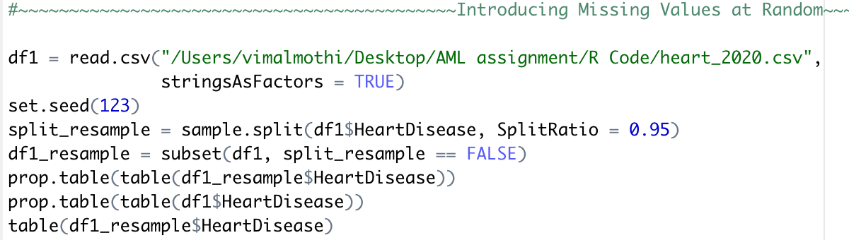

Figure : Creating scaled down dataset

The reduced dataset allows for reasonable computational time for SMOTE operation and building complex non-linear models. The outcome feature of this dataset is of binary class with “Yes” and “No” for heart disease. Details of each feature within the dataset is tabulated in the table below.

Table : Details of features within dataset

|  |  |  |  |
| --- | --- | --- | --- |
| No. | Features | Description | Data Type |
| 1. | HeartDisease | Reported having coronary heart disease (CHD) or myocardial infarction (MI) | Categorical |
| 2. | BMI | Body Mass Index | Numerical |
| 3. | Smoking | Smoked at least 100 cigarettes in your entire life | Categorical |
| 4. | AlcoholDrinking | Adult men having more than 14 drinks per week and adult women having more than 7 drinks per week | Categorical |
| 5. | Stroke | Respondents had/have stroke? | Categorical |
| 6. | PhysicalHealth | How many days during the past 30 days was your physical health not good? | Numerical |
| 7. | MenthalHealth | how many days during the past 30 days was your mental health not good? | Numerical |
| 8. | DiffWalking | Have serious difficulty walking or climbing stairs | Categorical |
| 9. | Sex | Male or Female | Categorical |
| 10. | AgeCategory | 13 Age category level | Categorical |
| 11. | Race | Race or Ethnicity of respondents | Categorical |
| 12. | Diabetic | Diagnosed with Diabetes | Categorical |
| 13. | PhysicalActivity | Doing physical activity or exercise during the past 30 days other than regular job | Categorical |
| 14. | GenHealth | Levels of general health | Categorical |
| 15. | SleepTime | How many hours does the respondent sleep in a 24 hour period | Numerical |
| 16. | Asthma | Diagnosed with Asthma | Categorical |
| 17. | KidneyDisease | Have any form of kidney disease not including kidney stones | Categorical |
| 18. | SkinCancer | Diagnosed with Skin Cancer | Categorical |

## 3.2 Models

### 3.2.1 SMOTE

In Machine Learning, SMOTE represents one of the most common approaches for balancing an imbalanced dataset. It is considered to be one of the most impactful pre-processing method for an imbalanced dataset (Fernandez et al., 2018). Using SMOTE, minority class are interpolated using K - nearest neighbour concept with the value of K being user defined. As mentioned by Sowjanya and Mrudula (2022), centroids of minority samples are measure and the distance between each minority samples and these centroids are calculated. Computing the averages forms a distance matrix from which a synthetic sample is created using random number generator between 0 and 1. The overall goal of SMOTE is to help models achieve generalization in classification tasks. In literature, there are many forms of SMOTE created for given studies. In this study, basic SMOTE from “performanceEstimation” R package would be implemented.

### 3.2.2 Logistic Regression

Logistic Regression is supervised learning algorithm whereby linear combination of variables is used to predict an output variable (Waqar et al., 2021). According to Chao-Ying et al.(2020), Logistic regression is based on logit, a natural logarithm of odds ratio. Logistic Regression is suitable for testing hypothesis with regards to relationships between categorical outcome feature and one or more categorical or continuous features. A logistic regression plot is known as a sigmoidal curve which is calculated used logit of Y from X (Wright, 1995).

### 3.2.3 Naïve Bayes

Naïve Bayes is a classification machine learning technique that adopts probabilities and statistical methods in prediction. According to Dulhare (2018), the simplicity of the algorithm coupled with its computational feasibility, makes Naïve Bayes a well-received machine learning technique in many fields. Naïve Bayes is based of Bayes theorem that contains three aspect – prior, posterior and class conditional probabilities. The equation of Bayes Theorem is as below:

$$P\left(Q | X\right)=\frac{P\left(X | Q\right).P(Q)}{P(X)}$$

P(Q|X) = Probability of Q given X

P(X|Q) = Probability of X given Q

P(Q) = Probability of Q

P(X). = Probability of X

### 3.2.4 Support Vector Machines (SVM)

SVM is supervised algorithm used for both classification and regression problems. SVM constructs a hyperplane as a separatable boundary with two other parallel hyperplanes enclosing the main hyperplane on which the support vectors are located. According to Durgesh and Lekha (2010), a unique property of SVM is its capability in simultaneously minimize empirical classification error while maximizing the geometric margin.. Generally the larger the reasonable margin between these parallel hyperplanes, the more generalized the classifier.

### 3.2.5 Decision Tree

Decision Tree is one of the tree-based algorithm that consist of a root node, internal nodes and leaf nodes. As mentioned by Goel (2021), every attribute is test according to the flow from Root to leaf node. The rules on each node determines the end classification or regression. Each branch indicates conclusion made from a test with leaf node supplying information about a single class label

## 3.3 Evaluation metrics

### 3.3.1 Confusion matrix

In a classification problem, confusion matrix centers as the main evaluation metric. The matrix compares predicted outcome against the desired outcome. An example of a confusion metric is shown below.

|  |  |  |  |
| --- | --- | --- | --- |
|  |  | **Actual Class** | |
|  |  | + | - |
| **Predicted Class** | + | **TP** | **FP** |
| - | **FN** | **TN** |

Figure : Confusion matrix

The confusion matrix is made up of few components namely TP = True Positives, TN = True Negatives, FN = False Negatives and FP = False Positives. With regards to this study, TP would be the Heart Disease patients predicted correctly, TN would be the Non-Heart Disease patients predicted correctly, FP will be Non-Heart Disease patients predicted as having Heart Disease and FN will be Heart Disease patients predicted as not having heart disease. From the confusion matrix other evaluation metrics are derived.

### 3.3.2 Sensitivity

Sensitivity derived from the confusion matrix is used to measure the amount of people to have heart disease out of the actual number of people to have heart disease. The formula to calculate sensitivity is as such :

$$Sensitivity/Recall= \frac{TP}{TP+FN}$$

In this study, as the dataset from the test set is kept imbalanced, sensitivity plays an important role as it help gauge how well the classifiers predict the minority class.

### 3.3.3 Specificity

Specificity is used to measure the probability of a negative test. In this study Specificity is used to measure how well the classifier is able to correctly identify people without heart disease. The formula to calculate specificity is as such :

$$Specificity= \frac{TN}{TN+FP}$$

### 3.3.4 Balanced Accuracy

As this study focuses on building a model to evaluate on an imbalanced test set, one evaluation metric that will be used to properly gauge the models capability in classifying both classes would be balanced accuracy. This metric focus on the average of specificity and sensitivity, allowing prediction of both classes to have equal weight on the overall results. Basic accuracy measure would typically be skewed as high prediction on the majority class can result in high perceived accuracy. Hence, balance accuracy is used over accuracy. The formula for balanced accuracy is as below:

$$Balaned Accuracy= \frac{Sensitivity+Specificity}{2}$$

# 4.0 DATA PREPROCESSING

This section encompasses the end-to-end data handling process to prepare the dataset for its downstream process of predictive modelling. The dataset is initially explored to understand the various features involved and its data types. From here missing values handled strategically based on the data types and existence of outliers. Failing to impute missing values can reduce statistical power of a study which would have high probability inducing bias within the overall developed model (Kang, 2013). The dataset is further explored graphically to understand its distributions across. To create a standard approach across all models, encoding is performed such that categorical features are converted to numerical representation.

## 4.1 Data Exploration

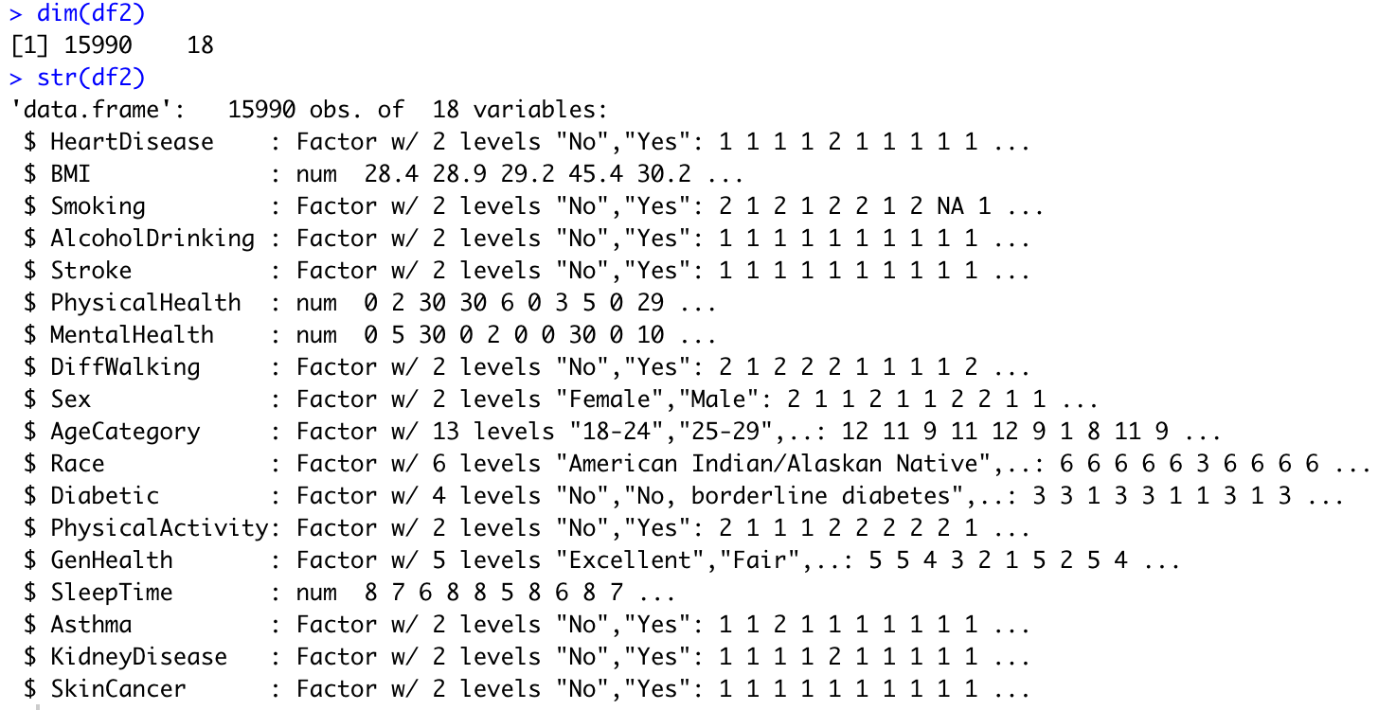

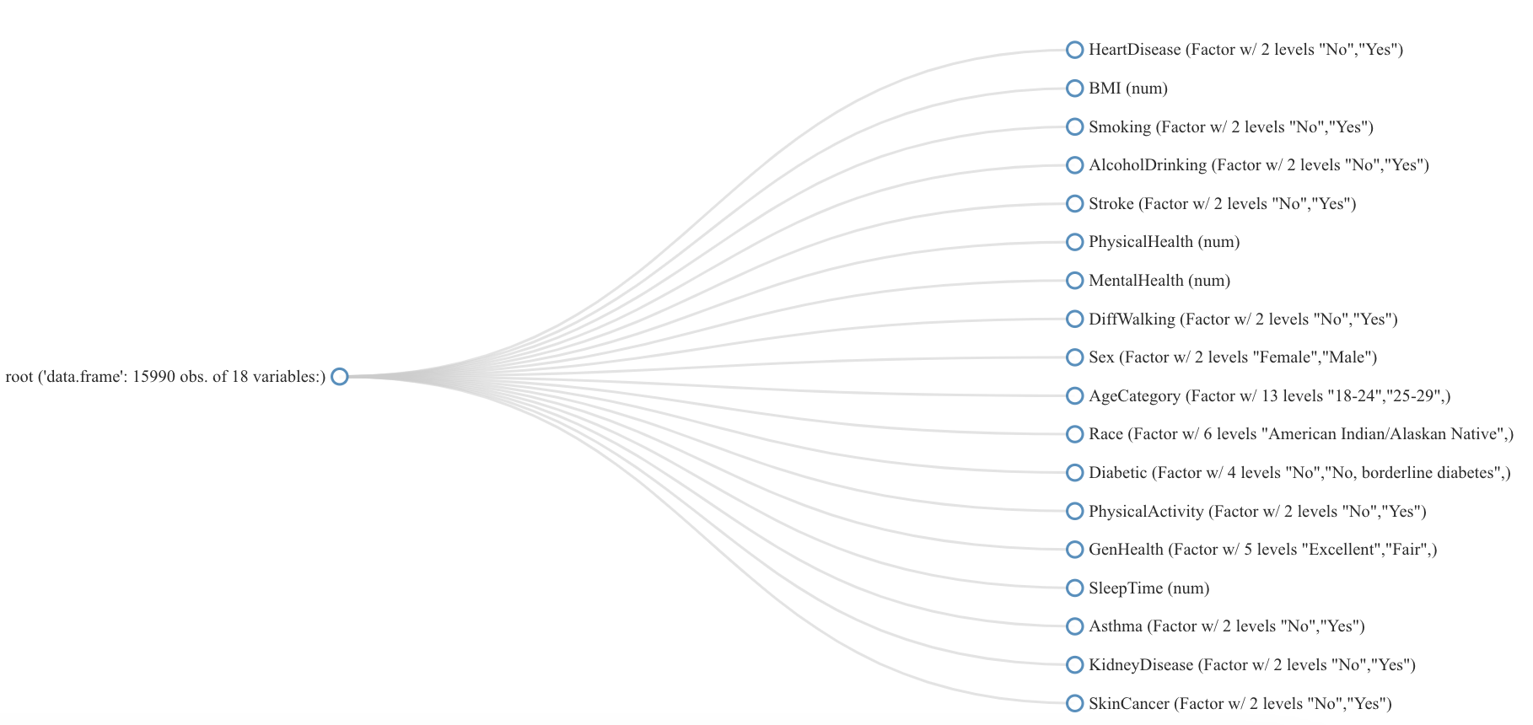

Figure : (Top) Dimension and Structure of dataset (Bottom) Structure plot

Figure 3 shows the breakdown of the dataset imported in R Studio. The dataset has the dimensions of 15990 observations and 18 features. Out of the 18 variables, 14 are categorical and 4 are numerical. Categorical variables were imported in as factors with each class known as levels in Figure 3. The outcome variable, HeartDisease is of binary class hence establishing the need for a binary classification predictor model. A structure plot is used to enhance the visual representation of features data types. AgeCategory has most number of levels, 13, followed by Race with 6 levels and GenHealth with 5 levels. Based on common understanding, AgeCategory and GenHealth would have a direct correlation with the risk associated in having heart disease. This would be further explored graphically in later section

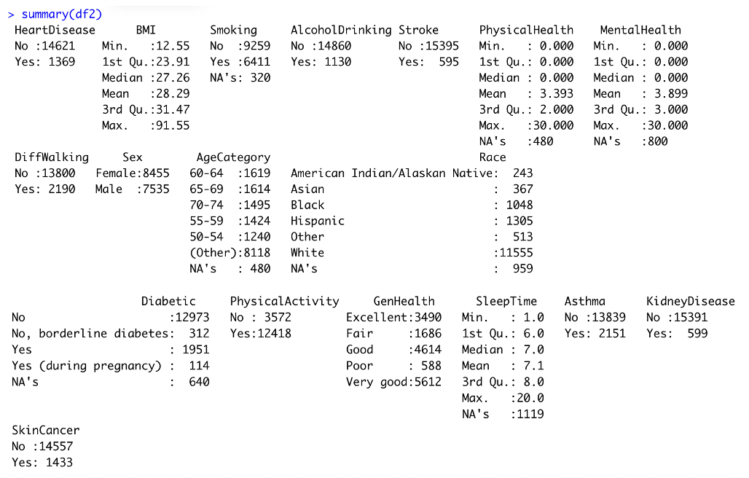

Figure : Dataset summary

From the summary statistics of the dataset, Figure 4, the outcome variable is imbalanced. “Yes” labels have 1369 observations while “No” labels significant outweighs the other class with 14621 observations. The same trend is seen across AlcoholDrinking, Stroke, DiffWalking, PhysicalActivity, Asthma, KidneyDisease and SkinCancer with one class heavily outnumbering the other. This might have influence on the imbalanced outcome variable. Features will be analysed in the feature selection stage. BMI ranges from 12.55 to 91.55 indicating a wide array of values. In addition to that, there are 7 values with missing values (NA’s)

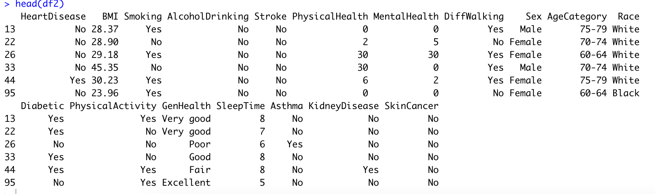

Figure : Dataset head values

Figure 5 prints outs the first few rows of the dataset. From the first few rows, it can be seen that the imbalanced features has the observations showing class imbalancents. This trend is expected to continue till the end of the dataframe. AgeCategory showcases older group of patients in the dataset indicating this dataset could consists of mostly older age group patients. Is is to be explored graphically in later section.

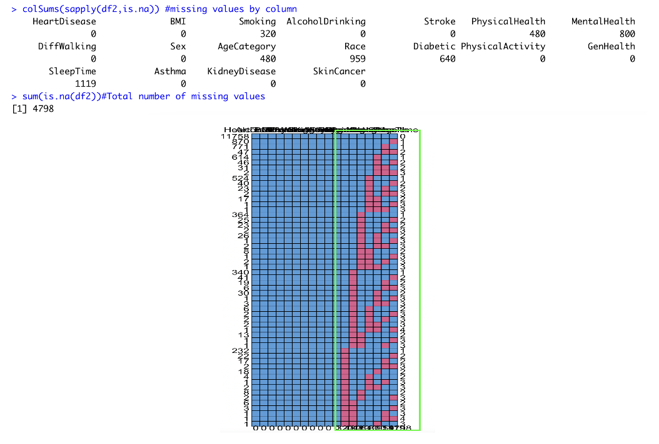

Figure : Missing Values

Using codes as in figure 6, missing values per column is queried. The breakdown of missing values is as such – Smoking with 320 values, PhysicalHealth with 480 values, MentalHealth with 800 values, AgeCategory with 480 values, Race with 959 values, Diabetic with 640 values, and SleepTime with 1119 values. From md.pattern(df2) plot, the missing values are concentrated on the rightside of the dataset. Total amount of missing values in the dataset is 4798 from 3 numerical features and 4 categorical features. The numerical features will be analysed for outliers to determine the right statistic for imputation. Categorical will have mode of the category imputed in the missing values.

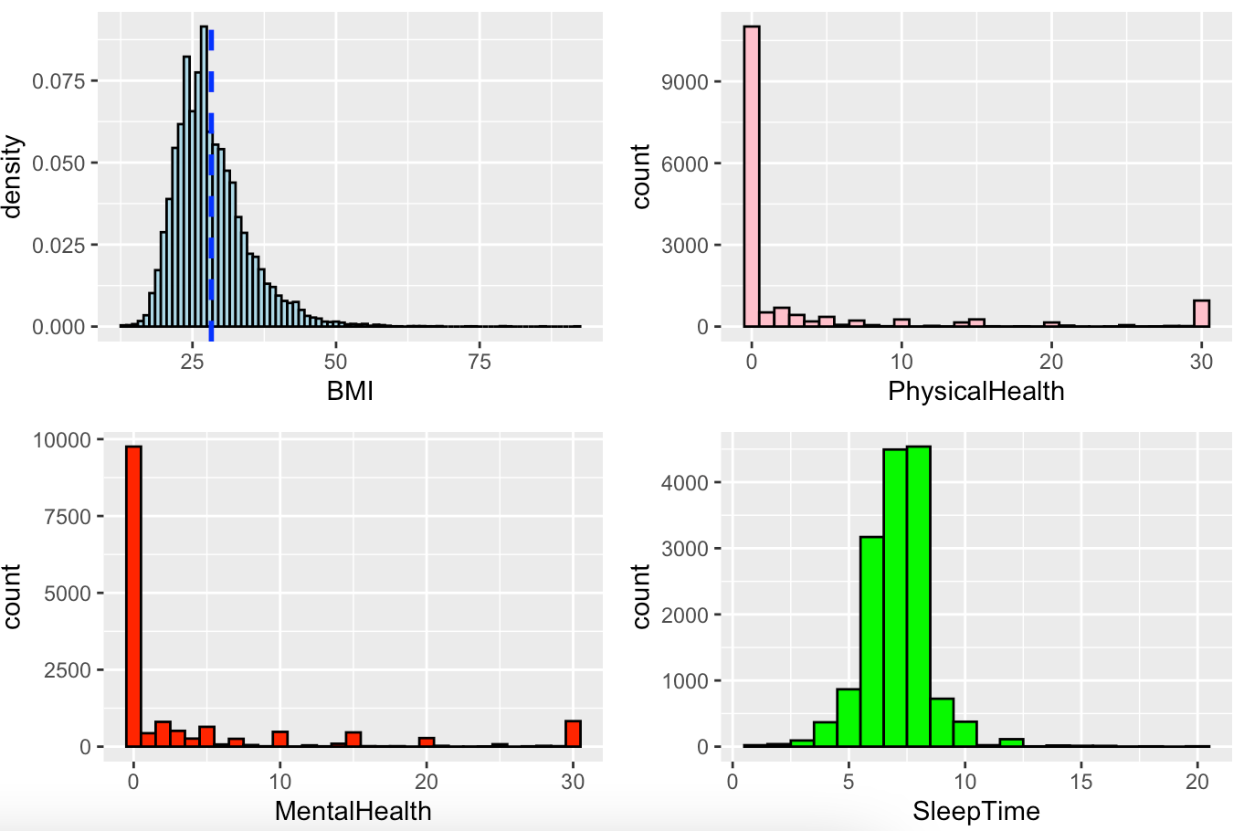

Figure : Histogram distribution of numerical variables

Numerical features are graphically represented as histogram such as in figure 7 to visualize its distribution. All the numerical features have some form of skewness to it. BMI distribution shows a right skewed distribution (+ve skewed) with Mode < Median < Mean. PhysicalHealth also has a right skewed distribution (+ve skewed) with Mode < Median < Mean. Values at the beginning and end of the range makes up most of the counts. The similar trend is seen across MentalHealth as it has a right skewed distribution (+ve skewed) with Mode < Median < Mean. Amongst the 4 numerical variables, SleepTime is the closest to Gaussian, however based on the range it should be categorized as right skewed with Mode < Median < Mean. In subsequent section, these numerical variables will be normalized using min max normalization in attempt to achieve a gaussian distribution.

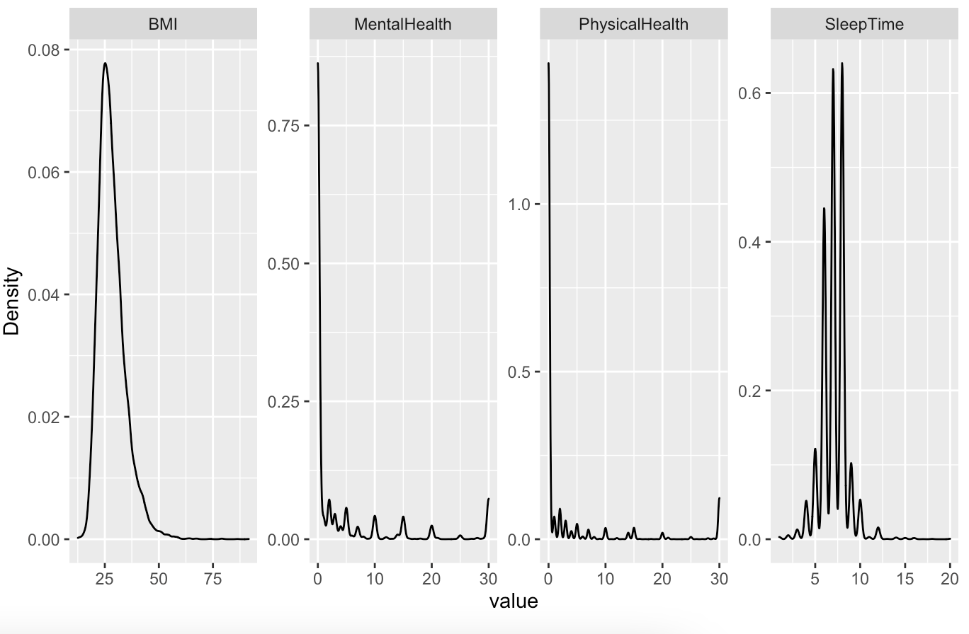

Figure : Density plot of numerical variables

The density plot of these 4 features further emphasizes its non-gaussian distribution. BMI has a rather smooth curve over its distribution indicating datapoints are more between 20 – 45. The distribution across SleepTime is much more staggered indicating gaps between datapoints. The same is for MentalHealth and PhysicalHealth. Normalization will be described in subsequent section in attempt to achieve a gaussian distribution

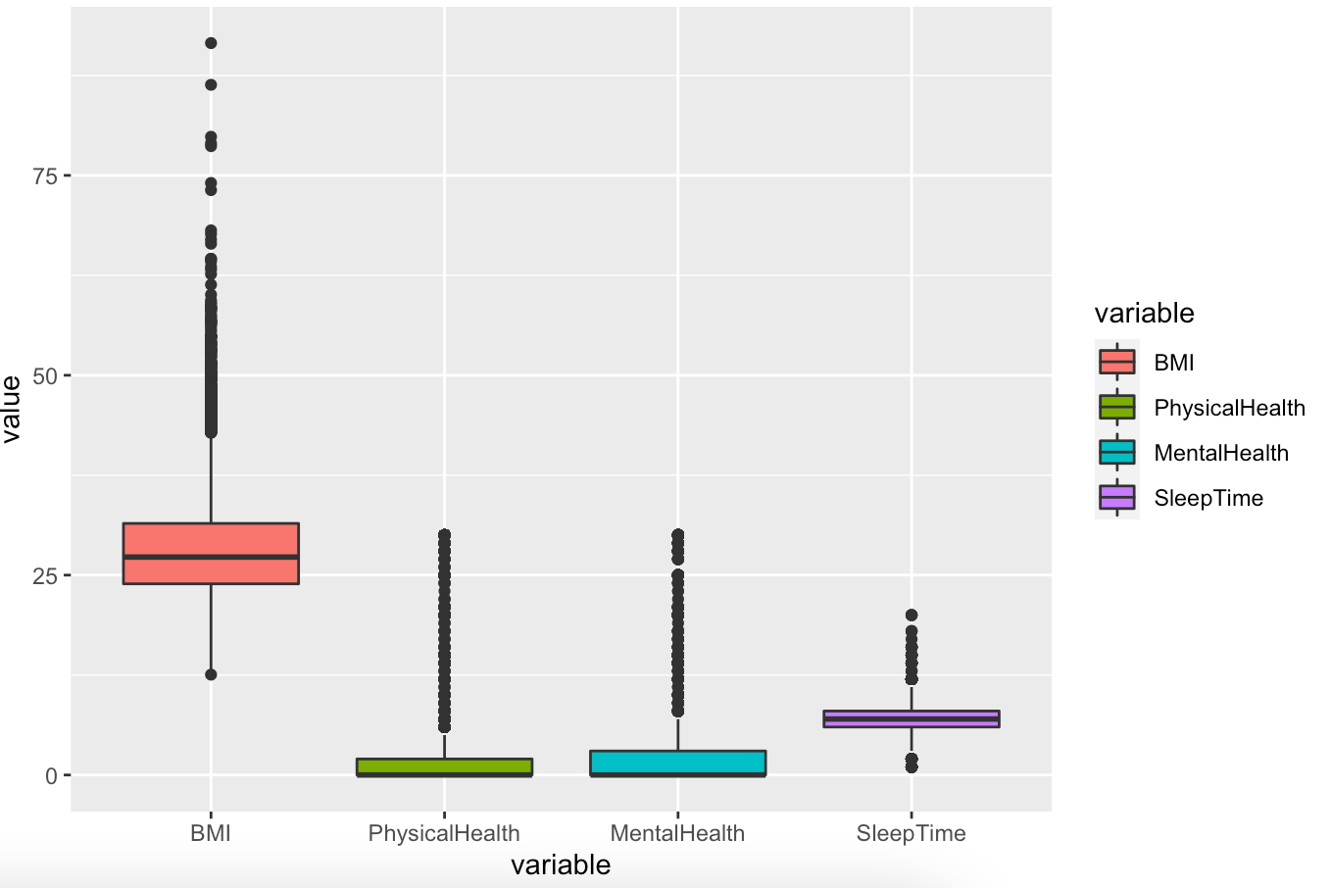

Figure : Boxplot of continuous features

From boxplots of these numerical features, Figure 9, there are presence of outliers across all 4 features. The range of values is largest in BMI with SleepTime having the smallest range. The minimum point for PhysicalHealth and MentalHealth Quarter 1 of its interquartile range. Outliers are much more disperse in BMI compared to the other 3 features. Due to the presence of outliers, the missing values of the numerical features will be imputed with median statistics.

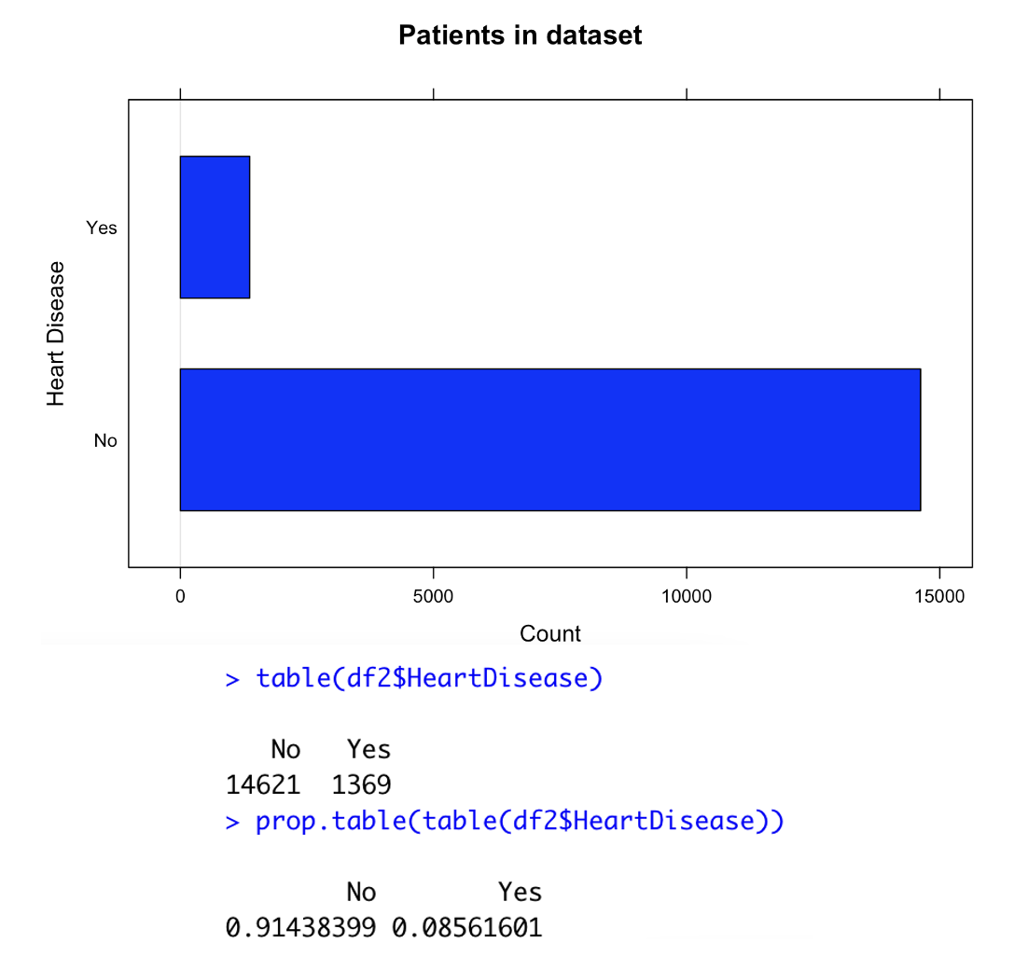

Figure : Imbalanced target binary class

Figure 10 is a barplot of the outcome variable of this dataset. Heart disease is of binary class, “Yes” and “No” with the “Yes” class being a minority class and “No” being the majority class. The minority class only makes up approximately 9 % of the entire dataset with the majority making up 91%. This data set will be balanced prior to training models to ensure the model developed is able to identify the minority class given an unseen dataset. The impact on balancing dataset has significant influence on a given models performance. In section 6.1, the effect of unbalanced data and balanced data on a model’s predictive ability will be evaluated.

## 4.2 Imputations

As mentioned as part of missing values in section 4.1, this dataset consists of missing values that would need to be treated before feature selection. The original dataset had no missing values, hence using delete_MCAR from missMethods package, missing values were introduced across selected features with individual percentages. The method used was missing completely at random. This ensure that there is no relationship between missingness of the data and any values, observed or missing.

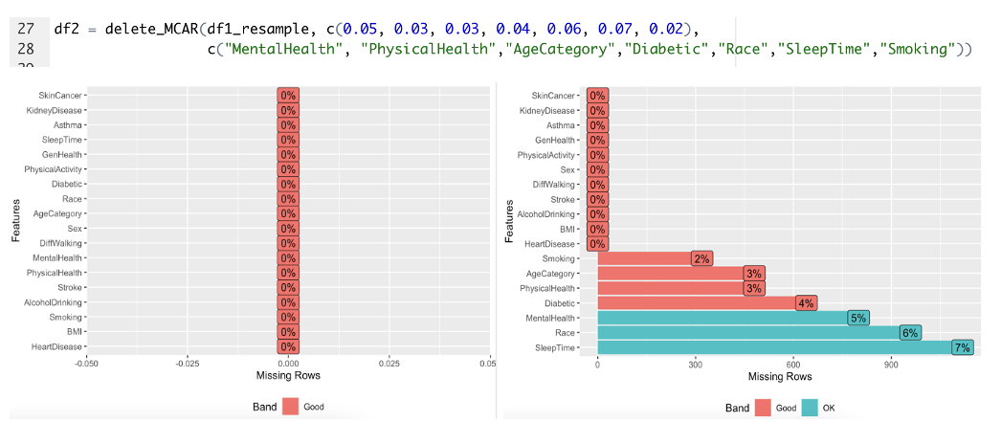

Figure : (Left) Original dataset (Right) Introduced missing values completely at random

Using the delete_MCAR() function as seen in figure 11, missing values are randomly inserted into the selected features. Using plot_missing() the visualization of missing values is shown. The breakdown is as such – Smoking, 8% missing ; AgeCategory, 3% missing ; PhysicalHealth, 3% missing ; Diabetic, 4% missing ; MentalHealth, 5% missing ; Race, 6% missing ; SleepTime, 7% missing. Based on the type of feature, Categorial or Numerical, the right technique is used to impute these missing values.

## 4.2.1 Numerical Imputations

Based on the boxplot in 4.1, all the numerical features have outliers in its distribution. As such median statistics is used to impute into the missing values across each feature.

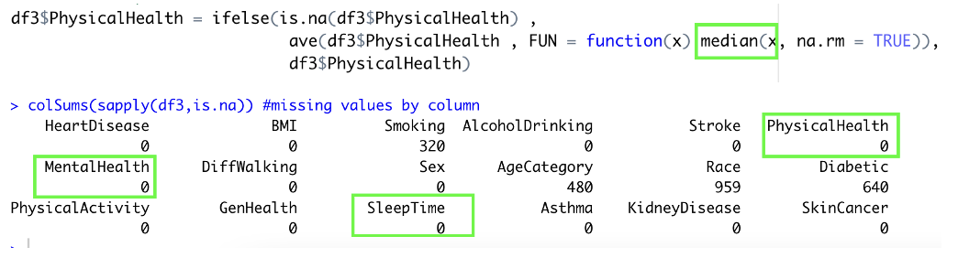

Figure : (Top) Median Imputations example (Bottom) Imputed features

Figure 12 top shows a code snippet for 1 of the numerical imputations performed. Median statistic is used to impute the values into the missing values of PhysicalHealth. The same is repeated across all 3 features. Based on the missing values by column, it shows that numerical imputations are successful such that the 3 features no longer contain missing values.

### 4.2.1 Categorical Imputations

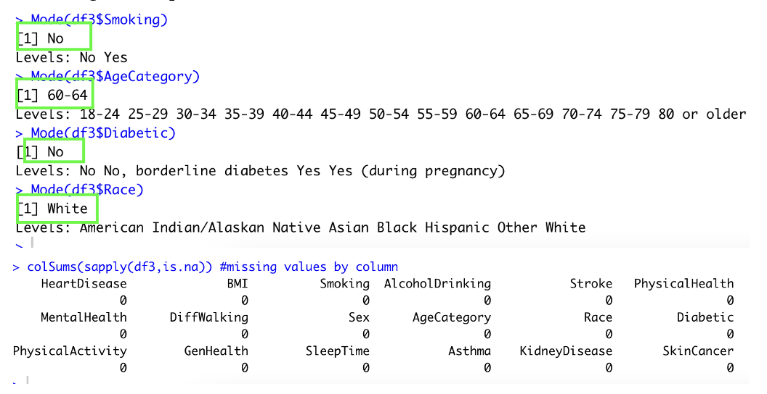

Figure :(Top) Mode values to be imputed (Bottom) Imputed dataset

Figure 13 shows mode imputations performed for missing values in categorical features. From mode analysis, it identified that the mode to be imputed for each feature is as such – Smoking: No, AgeCategory : 60-64, Diabetic : No, Race : White. A function is used to loop imputations for these mode values into the missing values of each respective features. Post imputation, missing values per feature of the dataset is evaluated and results shows that all missing values have been successfully imputed.

## 4.3 Exploratory Data Analysis

The imputed dataset is further explored to understand trends across several variables and its influence over the outcome variable. Based on assumption that patients with heart disease typically are of older age, have underlying health issues and generally unhealthy, features are plotted to extract insights from any possible clear trends.

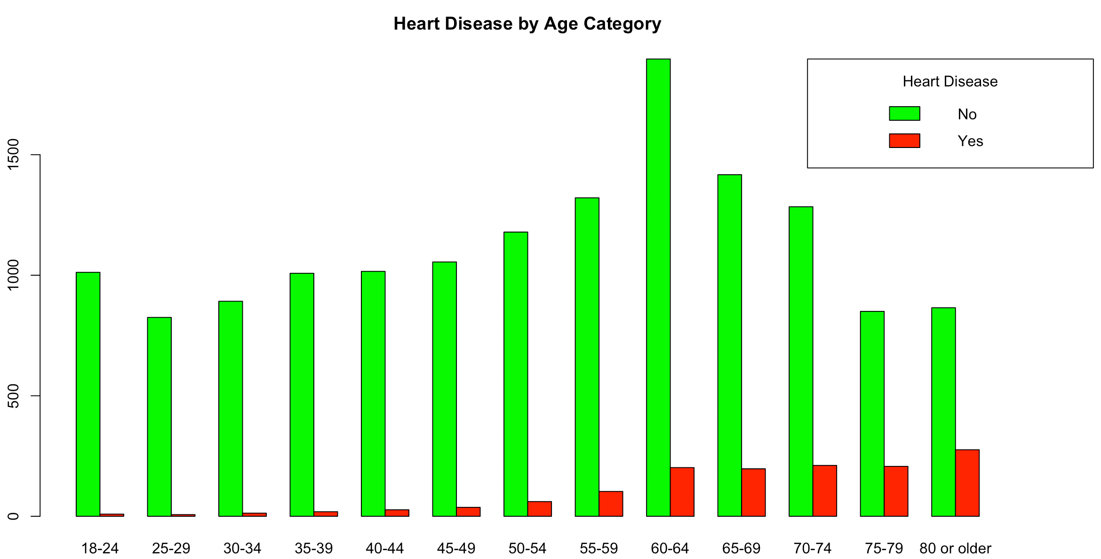

Figure : Heart Disease grouped by Age Category

From further exploration of the data, Figure 14, most patients in the dataset are between ages 50 and 75. By analysing the trend across patients with heart disease, it aligns with initial assumption that as age increases, patients per age category with heart disease will also increase. In this dataset, ages 80 or older has the most patients with heart disease. Although most patients are within the ages of 60-64, the ratio of patients with heart disease and without heart disease is significantly higher in ages 80 or older. Hence, from analysis, age category has significant influence on patients with heart disease.

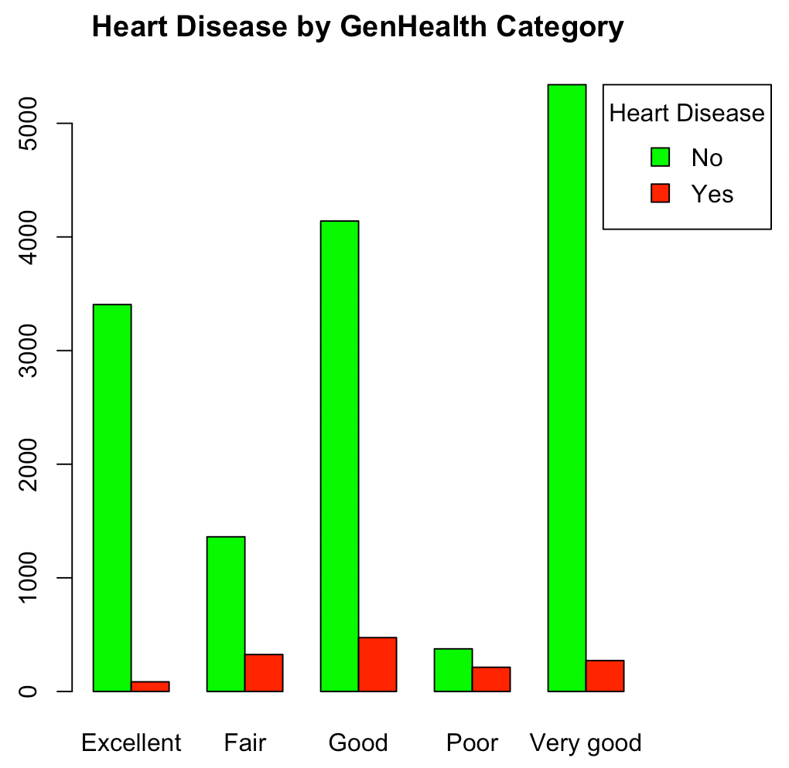

Figure : Heart Disease grouped by GenHealth category

Based on Figure 15, general health also does play a role in patients being diagnosed with heart disease. Generally, if patients have lower immune system with underlying medical conditions are more suspectable to contracting heart disease. From the plot in figure 13, most patients in the dataset have very good health with least number of patients having fair or poor health, justifying the imbalanced data with “No” as the majority class. Although most patients with heart disease are of good health, the percentage of patients with heart disease by group is highest in poor health. This indicates that the probability of being diagnosed with heart disease is very much higher if the patient’s general health is at the lower end of the spectrum

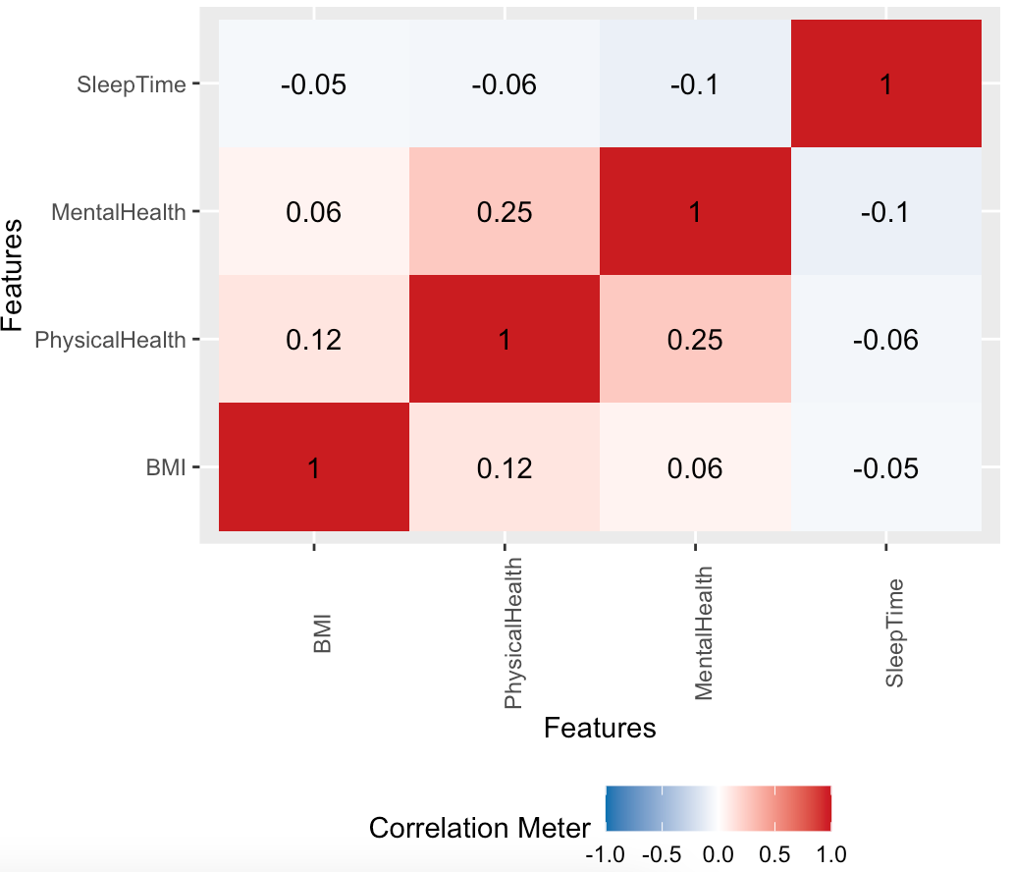

Figure : Correlations of numerical features

A correlation plot is performed to check for collinearity between predictor variables. If the predictor features are highly correlated, this would affect models such as logistic regression with presence of singularities and models like naïve bayes that assumes predictor variables are completely independent or unrelated to the presence of any other feature. From correlation plot, all features have low correlation values with the highest being mental health and physical health having a correlation of 0.25. This low correlation values concludes that the features are independent of each other and suitable to use for modelling.

## 4.4 Normalization

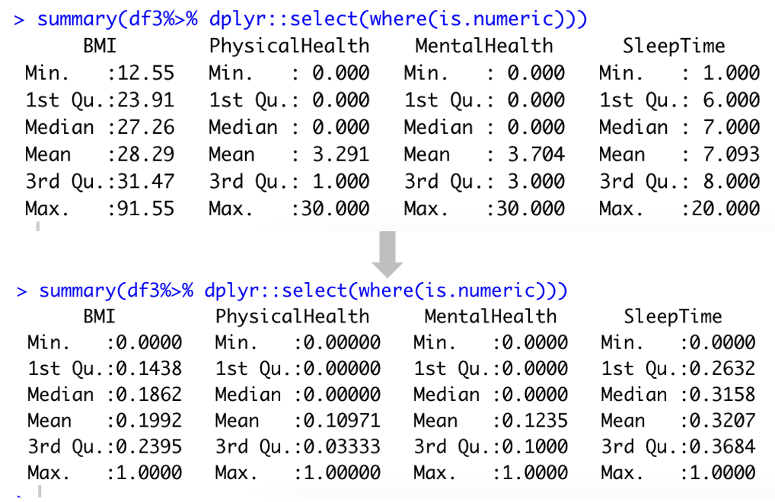

Figure : Before and After min-max Normalization

Using min max normalization, all the numerical features were scaled down to ranges of 0 – 1. This process of normalization is important to reduce the dominating influence of one feature against the other. This is specifically important for distance-based classifiers. BMI in this case has the largest range of values which potential overpower its influence against other numerical features. Post normalization, the ranges of all 4 numerical features were scaled between 0 – 1 with SleepTime have the highest mean value across the three. This linear transformation is applied in view of transforming the skewed distribution into a normal distribution preferred for various model building in subsequent sections.

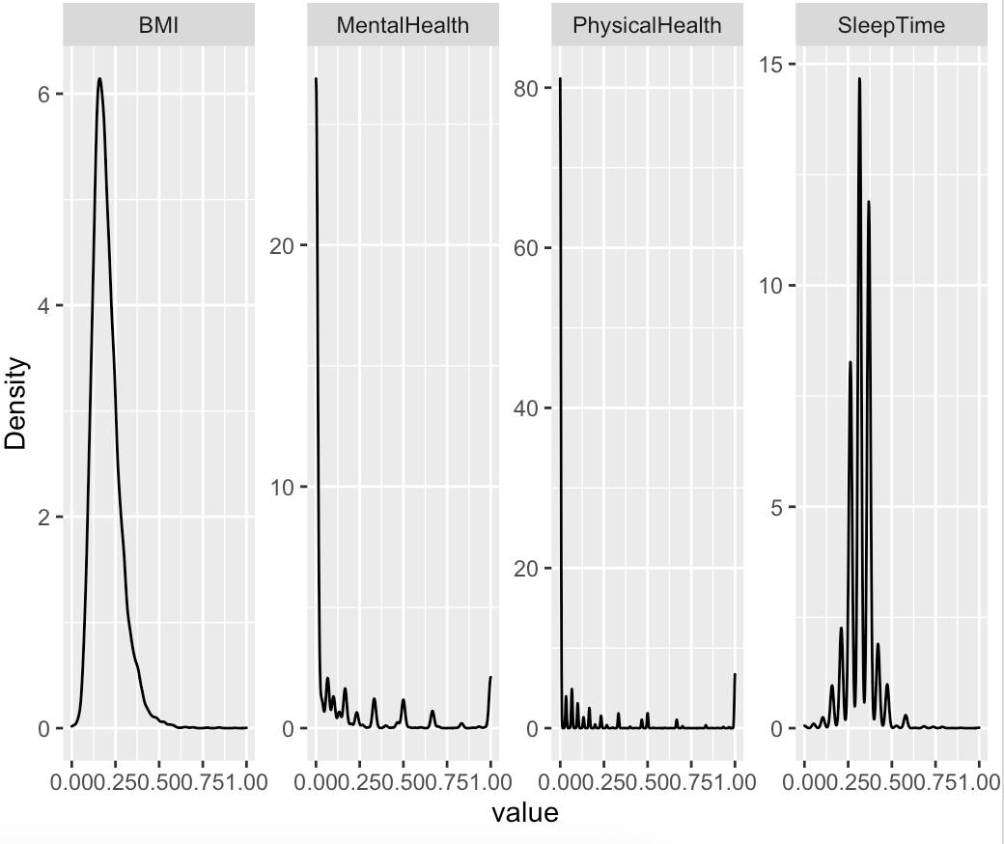

Figure : Density plot after normalization

From figure 18, even post normalization, the distribution does not shift much. All the distribution are still skewed between the ranges 0 to 1. For this given dataset, the skewness is relatively high that min-max normalization is not capable of transforming it into a normally distribution feature. This distributions post normalization is taken into consideration during model building.

## 4.5 Encoding

As this dataset is categorically heavy, the features would need to be transformed into numerical representations to standardise the dataset being trained across all the models. Although some models in this report do not required encoding such as Naïve Bayesian and Tree based models (Random Forest and Decision Tree), the dataset is encoded as it’s needed for logistic regression and support vector machines models. Only the encoded dataset is used to build these models to have fair comparison on each model’s performance. In this dataset, 2 types of encoding is used to accommodate the categorical data types. Ordinal encoding is used for categorical features whereby the levels are ordered and have influence of the outcome feature, where else One – Hot encoding is used for nominal categorical features.

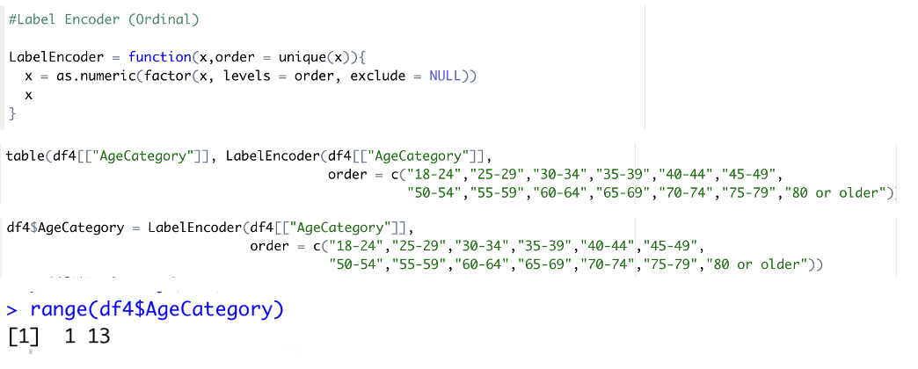

Figure : Label Encoding

Figure 19 showcases a sample label encoding performed to encode AgeCategory feature. As per EDA, risk associated with contracted heart disease increases as age increases. Hence levels are assigned to order age category from young to old indicating that older patients have higher probability of having heart disease. A Label Encoder function is written as seen in figure 17 that takes feature as an input as well has uniquely ordered levels. The table function is used to check if levels are ordered as per numerical sequence with 1 being lower age group and 13 being higher age group. From here the label encoder function is used to replace the levels with its ordered numerical representations. The same is repeated for GenHealth feature.

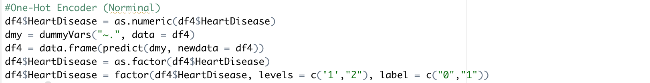

Figure : One-hot Encoding

For other nominal categorical features, one hot encoding is used to transform the levels into numerical representation. Most features are transformed into binary columns of “Yes” and “No” except for Race and Diabetic. One hot Encoding breaks the 1 column feature into the various columns based on the number of levels for each nominal feature. For example, the AlcoholDrinking feature is broken into 2 columns of AlcoholDrinking.Yes and AlcoholDrinking.No since the original feature has 2 levels. Using the functions as in figure 18, as the outcome feature is a factor, it is transformed to numeric first to avoid being encoded. Using dummyVars() the other categorical features are encoded and predicted values with predict() are assigned to a data frame. Following that, the outcome feature, HeartDisease is converted back into factors with levels re-assigned to 0 and 1 – 0 for “No” to HeartDisease, 1 for “Yes” to HeartDisease.

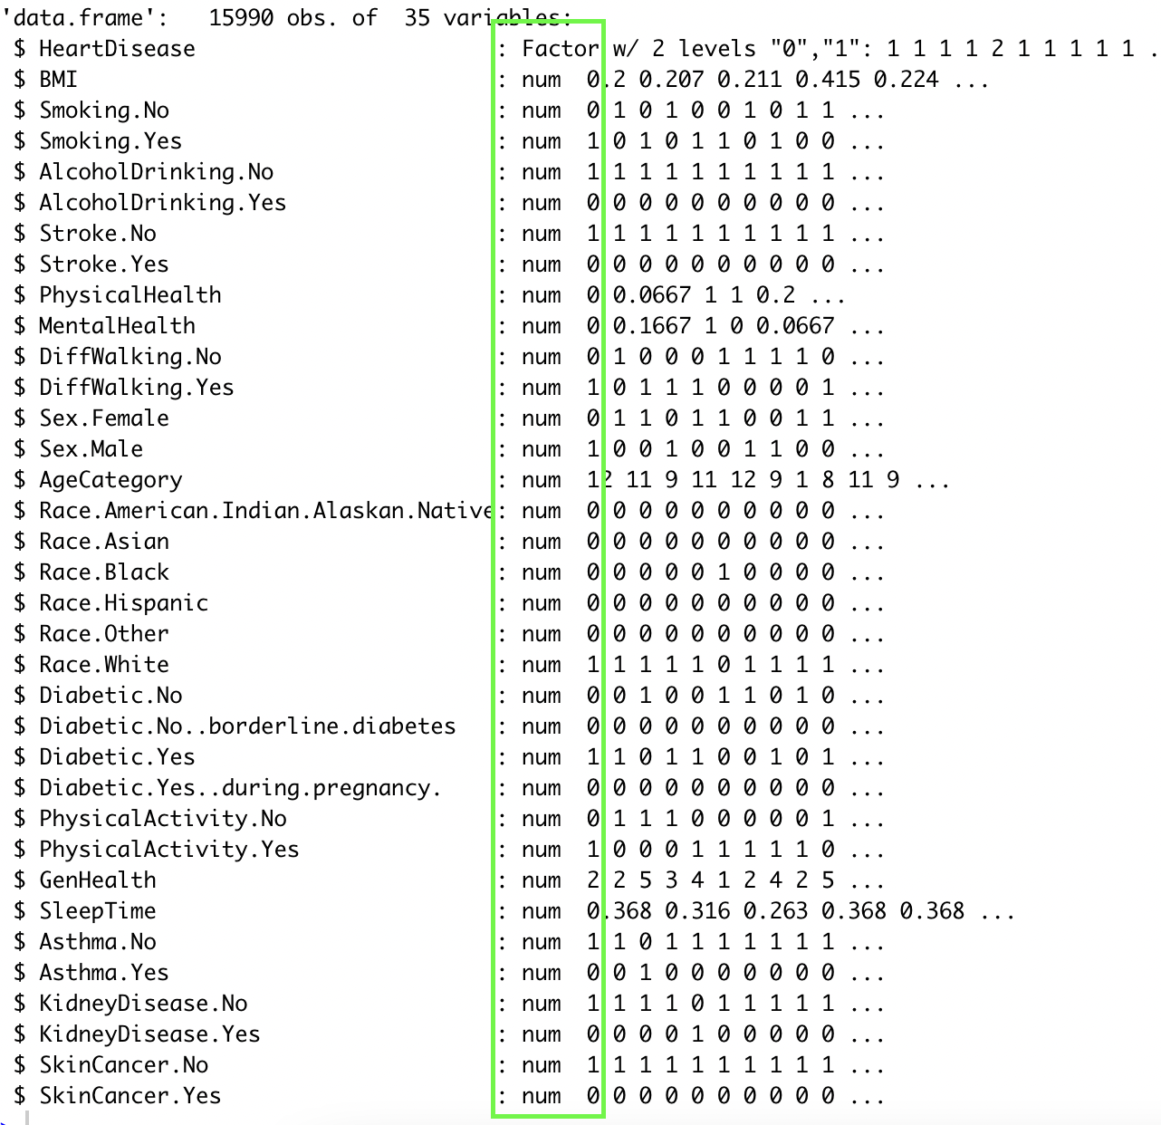

Figure : Structure after encoding

The final encoded dataset that is passed into feature selection stage is as above, Figure 21. All the predictor variables have been converted to encoded values as per data pre-processing stage. The outcome feature, HeartDisease is maintained in factor is needed in prediction of a classification problem. Each nominal feature is broken into number of columns as per the number of levels within the given feature. Ordinal feature, such as GenHealth and AgeCategory maintains as a single column feature with numerical ordered representations of the level. As such the number of features of the encoded dataset increased from 18 features to 35 features.

# 5.0 FEATURE SELECTION

In view of developing refined machine learning models, the dataset is analysed to understand critical features that would significantly influence the outcome feature. With a total of 35 feature variable, the model developed would have a higher risk of overfitting due increased mode complexity. Using Boruta package, a model is trained to extract key features based on feature importance values.

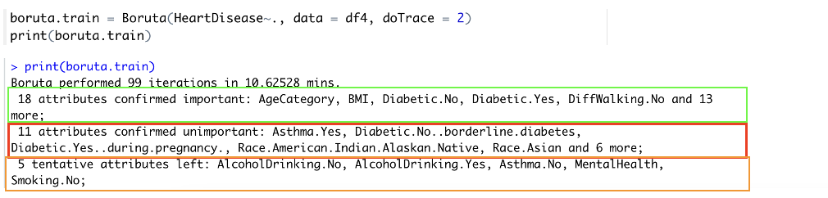

Figure : 1st iteration of Boruta Feature Selection

Boruta is 1st ran with 100 max iterations to identify important variables in predicting HeartDisease. From the first run, 18 attributes were confirmed important with 11 confirmed unimportant. After the 1st run, 5 attributes were left as tentative as the model couldn’t determine the importance values in comparison to other features.

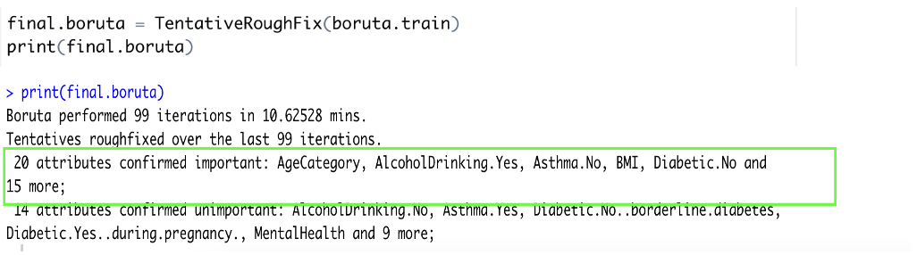

Figure : Final Boruta Iteration

The 2nd run is used to fix the tentative features and classify it as important or unimportant. The final Boruta outcome as per figure 23, shows 20 attributes confirmed important and 14 attributes were confirmed as unimportant. From here the 20 attributes will be added together with the outcome variable to form a new dataset for model building.

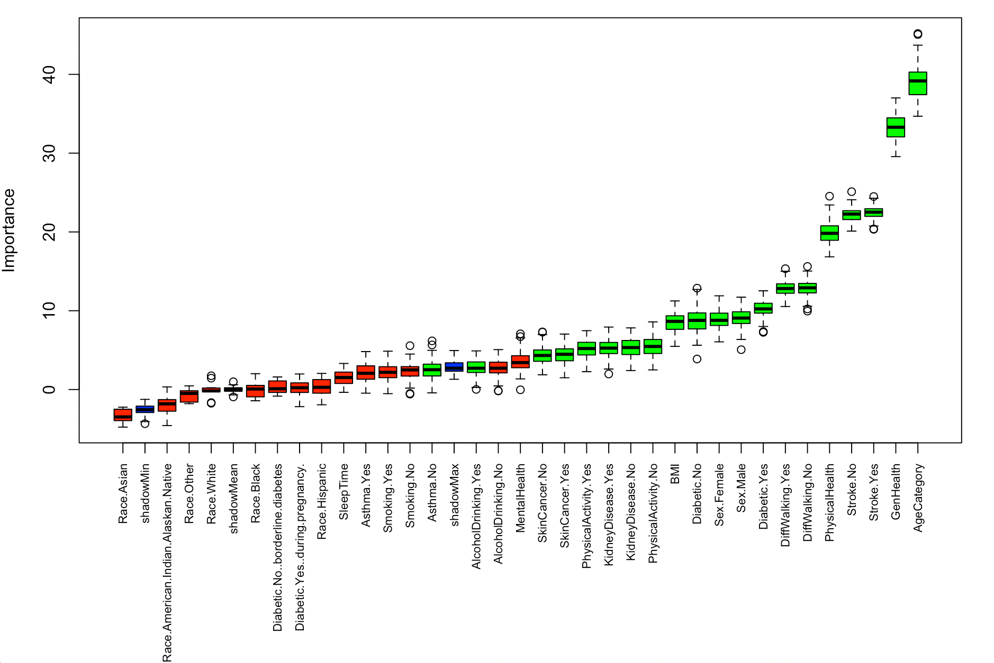

Figure : Boruta Feature Importance Plot

The results from Boruta outcome are plotted to visualise the importance of each feature in relation to other features. From the plot, the green boxplot corresponds to confirmed features while red corresponds to rejected features. The blue features correspond to minimal, average, and maximum Z score of the shadow attributes. From the plot AgeCategory and GenHealth have high importance in predicting the outcome feature as hypothesized in section 4.3. Both these features have importance significantly higher that other features within boruta’s analysis. In addition, that the importance score within AgeCategory and GenHealth have a large range in importance values indicating a change by 1 ordered level would significantly influence the prediction outcome. PhysicalHealth numerical features and Stroke also do have importance in determining the outcome variable. Patients with Stroke also have high importance in determining the outcome variable. From the importance plot, Physicalhealth also has a large range of importance based on its numerical distribution.

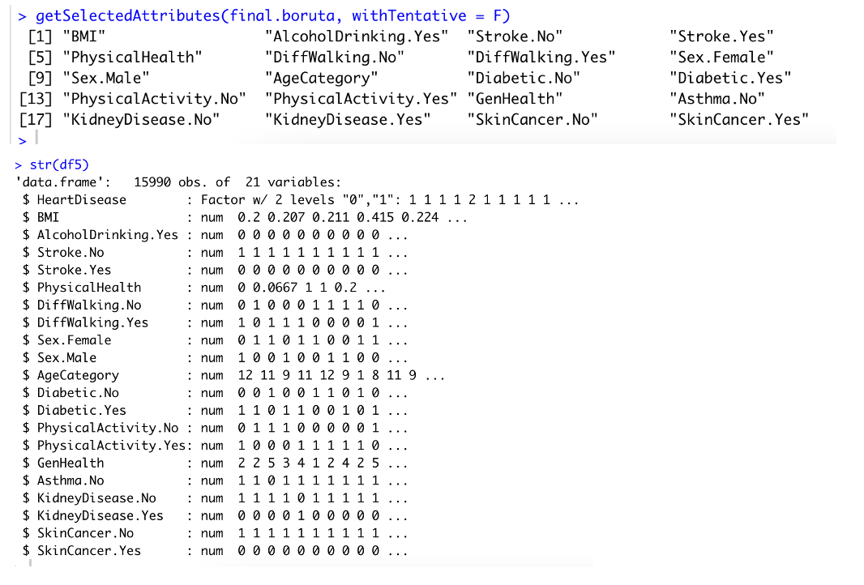

Figure :(Top) Confirmed Features (Bottom) New Dataframe with selected features and outcome variable

Using getSelectedAttributes() the final confirmed variables are extracted and set in a vector. It is then merged to extract the confirmed variable from the encoded dataset to produce the final dataset to be used for modelling. From figure 25, the below output showcases the structure of the final dataset. The final dataset contains important predictive features based on Boruta Feature Selection technique for modelling with normalized, encoded, and imputed values.

# 6.0 MODEL IMPLEMENTATION

In this section, the models developed and tested will be report together with the prediction outcomes from its confusion matrix and other evaluation metrics. ROC curves will also be evaluated the gauge the performance of each model on the given test set. To check for model fitness, each model’s predictive outcome in both training and test is evaluated to analyse for possible overfitting or underfitting. As the data used is imbalanced with majority class being “0” and minority class being “1”, an experiment is ran to test the reliability of models prediction outcomes using an imbalanced dataset and a balanced training dataset. The experiment is run only for Logistic Regression and the reliable approach is adopted and extended in model building across other algorithms. All models were then compared to evaluate each model’s performance for the given dataset. The description of each experiment is summarized below.

Experiment 1: Developed Logistic Regression predictive model for both imbalanced and balanced data. Balanced data has oversampling and under sampling performed for training set only to preserve an unseen test set scenario and to evaluate the model’s capability in predicting an imbalanced dataset. Evaluate the outcome and determine which approach to utilize for building models using other algorithms

Experiment 2: Using reliable train and test set, develop models using various other algorithms and evaluate the outcomes. Compare the performance on test and train set within each model to comment on model fitness and compare the performance on test set amongst each model to evaluate the best performing model.

## 6.1 Splitting Dataset

As this is a classification problem, the dataset is split into training and test set using stratified sampling technique with a split ratio of 0.8. With the true proportions of majority and minority class, the test and training dataset maintains the same proportions each to reflect that of the main dataset.

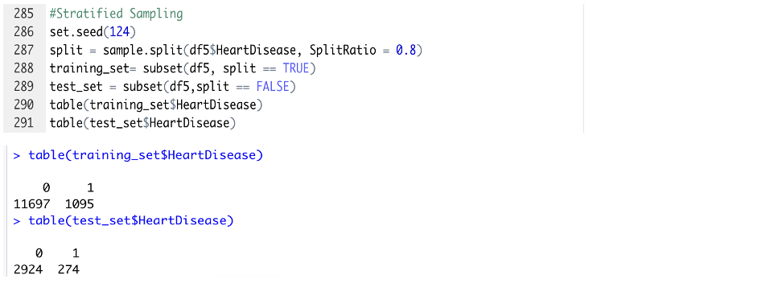

Figure : Stratified Sampling of training and test set

From Figure 26, the dataset is split into training set with 11697 observations for majority class and 1095 observation for minority class. The remaining proportions are kept in the test set with 2924 majority class and 274 observations for the minority class.

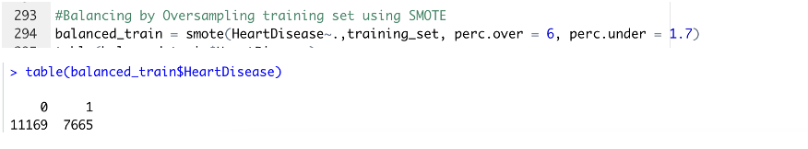

Figure : Smote training dataset

To perform experiment 1, the training set split is passed through SMOTE function in view of balancing the dataset. With HeartDisease as the outcome feature, the minority class is oversampled 6 time that of its original amount. For each new instance created for the minority class, 1.7 observations are taken from the majority class. Hence the minority and majority class would be oversampled and undersampled as such:

**Minority Class Majority Class:**

1095 x 6 = 6570 Undersampling = Oversampled data x 1.7

Oversampling = 6570 + original minority data = 6570 x 1.7

= 6570 + 1095 = 11169 Observations

= 7665 Observations

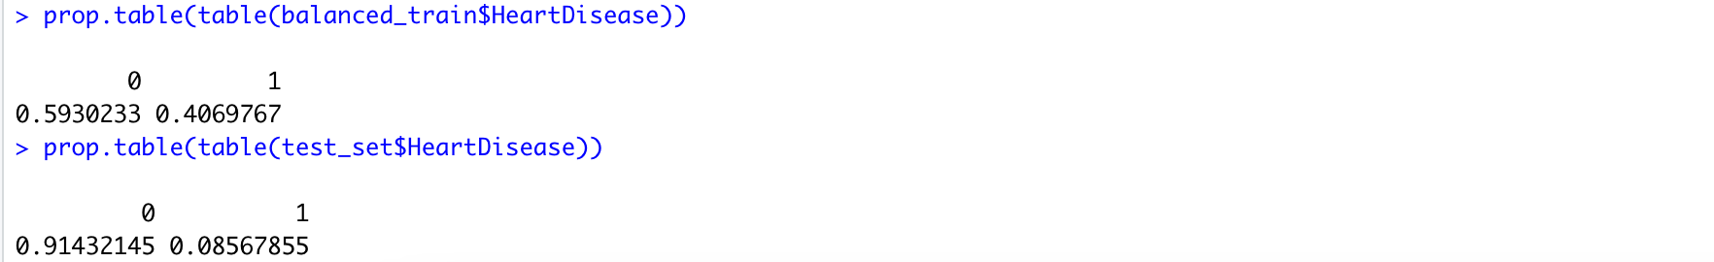

Figure : Proportion Table of balanced dataset

Figure 28 shows the final proportion table for balanced dataset. Note that the balancing is only performed for training set and not for the test set. This is to test the developed models in classifying both classes. Balancing is also performed after training and test split to prevent data leakage. Figure below shows the process flow of splitting datasets for both experiments.

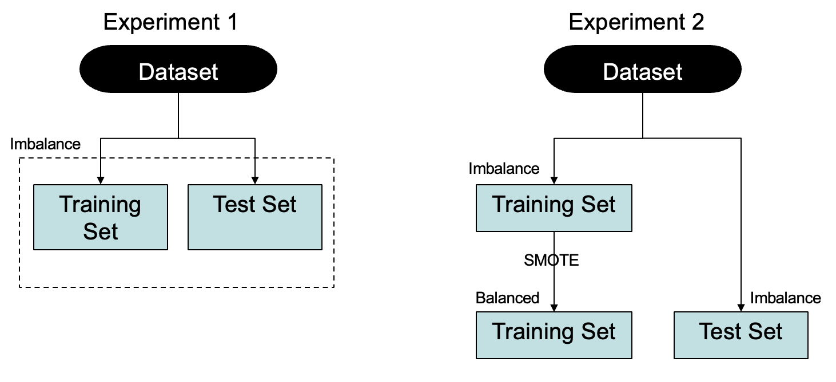

Figure : Splitting of dataset for both experiment

## 6.2 Logistic Regression (LR)

### 6.2.1 Experiment 1

In this experiment, a logistic regression model is built to test on both the default unbalanced dataset and a balanced dataset. Model is built using glm method from pre-existing stats package. As part of its parameter, family is set to binomial as it is a classification problem

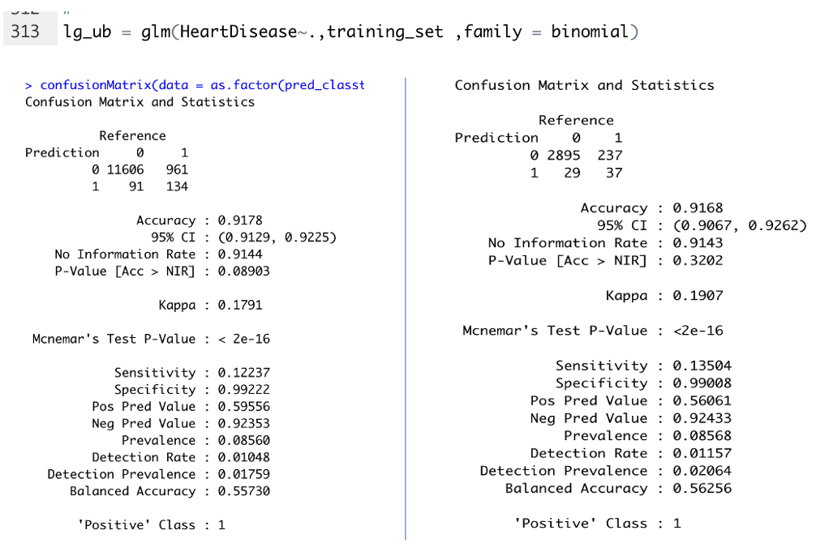

Figure : Unbalanced dataset Confusion matrix for (left) Training set and (right) Test set

In case 1, figure above, the evaluation metrics the accuracy produced is relatively high at 0.9178 for training set and 0.9168 for test set. These accuracy from both training and test set are close hence indicating that this model is a good fit. However, going beyond accuracy alone, the confusion matrix itself is undesirable. In the training set, although the model successfully predicted the negative class with high accuracy (11606 out of 11697), the positive class which also is the minority class in this dataset is badly misclassified. Only 134 out of 1095 positive class were predicted correctly with most of it being misclassified as False Negatives. This is also reflected across the Kappa value of 0.1791 with sensitivity being 0.12237. The sensitivity value describes only 12.237% of actual positive value were classified as True Positives. The best measure for this case would be the average between sensitivity and specificity which would be balanced accuracy. As seen in the diagram above, balanced accuracy is only 0.557 which is unreliable. This pattern is same for the evaluation metrics in test set. In case 1, the model has been well trained for prediction of majority class but performs terribly in predicting the minority class.

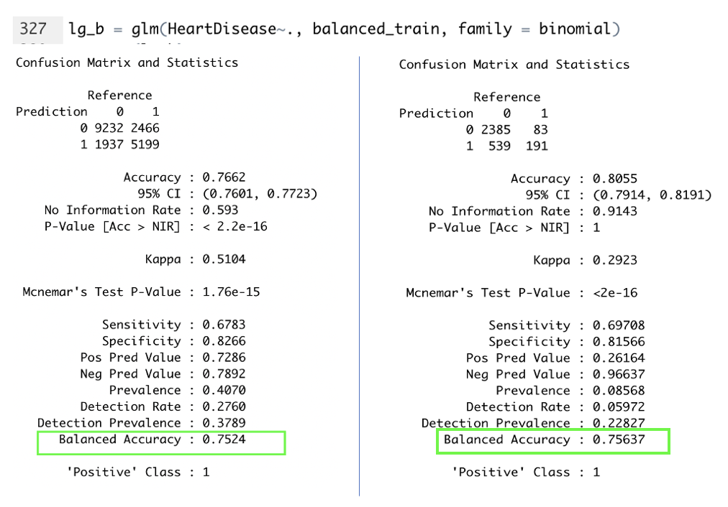

Figure : Confusion matrix for (left) Training set – Balanced, and (right) Test set - Unbalanced

Using the balanced training set, in case 2 the model developed was much more capable of classifying the minority class. The trade-off here is that the model does lose some potential in classifying the majority class since both labels are close in quantity to each other. From the figure above, the balanced accuracy across both training and test set in case 2 is 0.7524 and 0.75637 which indicates good fit. Although specificity is lowered slightly compared to case 1, the sensitivity is increased significantly. This trade off would be much more desirable than just being able to predict the majority class. In Heart Disease classification, the goal would be to decrease False Negatives as much as possible as this have much more severe consequences. For training set, the sensitivity and specificity are 0.6783 and 0.8266 while for training set it is 0.79708 and 0.81566. In addition to that the Kappa values also increase in the test set 0.1907 in case 1 to 0.2923 in case 2 which is classified as fair on the Kappa Scale.. By balancing only the training set, the true performance of the model can be evaluated with the test set as it maintains a completely unseen setting as well as disproportional outcome labels. The expectation is that model built on a balanced dataset with synthesized minority class should be able to perform give an unbalanced dataset too. Using approach in case 2, this technique is adopted in building various other model to compare each algorithms performance for the given classification problem.

### 6.2.2 Experiment 2

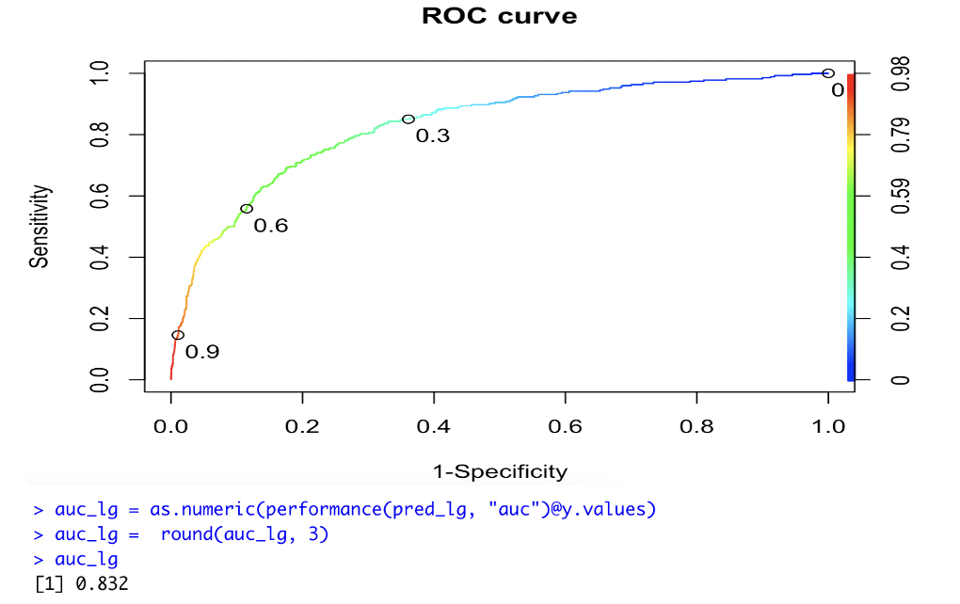

Figure : ROC - AUC for LR model

Using the prediction outcomes in case 2 from experiment 1, the model building process is extended to plot an ROC curve and measure its AUC. From the figure above, the ROC curve indicates the model has high probability in classifying both classes correctly such that it would be significantly above a random classifier. In being able to distiguish between patients with and without heart disease, the AUC is at 0.832 which is good.

## 6.3 Naïve Bayes

### 6.3.1 Naïve Bayes Basic (NB_basic)

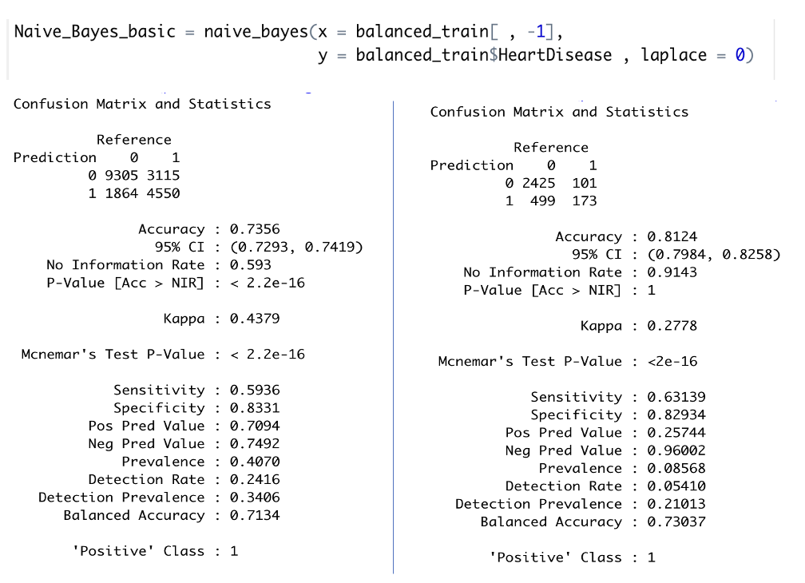

Figure : NB_basic evaluation metrics for (Left) Training set (Right) Test Set

From the figure above, using naïve bayes basic model with Laplace = 0, the balanced accuracy between training and test set is 0.7134 and 0.73037 indicating good fit. The Kappa value of the test set is also fair at 0.2778 with sensitivity of 0.63139 and specificity of 0.82934. From the test set confusion matrix, the model can correctly classify more than half of the minority indicating that the synthesis minority class in the training set is able to train the model to perform well in classifying minority classes in an unbalanced dataset.

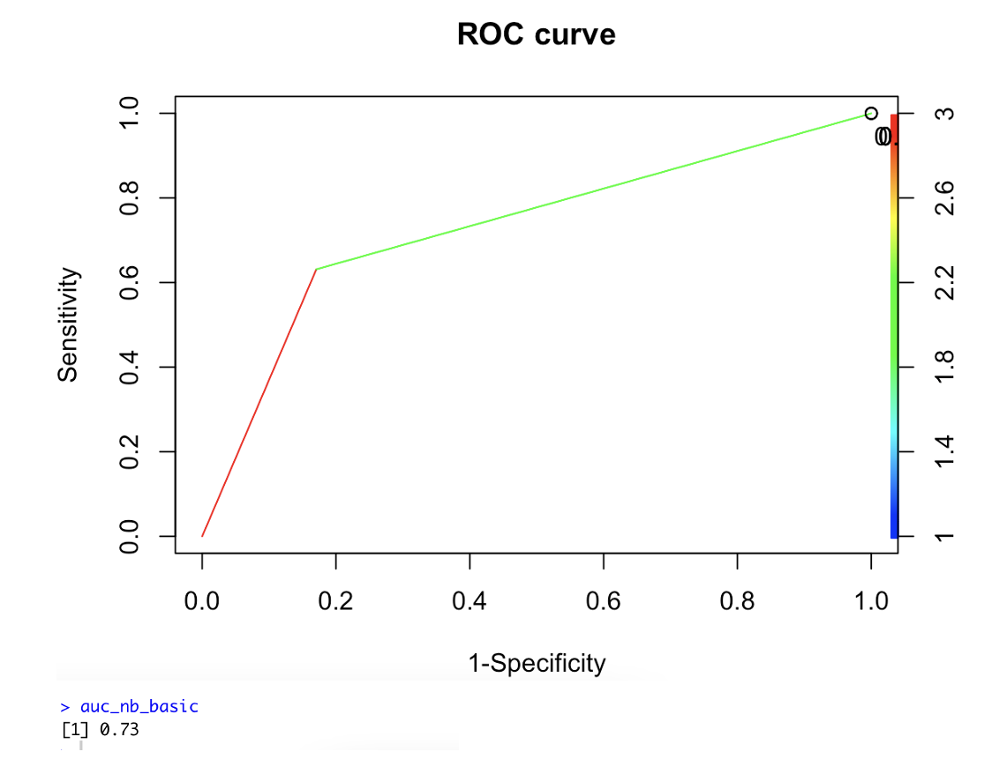

Figure : ROC - AUC for NB_basic model

From the figure above, NB_basic model’s ROC curve indicates the model has high probability in classifying both classes correctly such that it would be significantly above a random classifier. In being able to distiguish between patients with and without heart disease, the AUC is at 0.73 which is fair.

### 6.3.2 NB Laplace Smoothing (NB_lp)

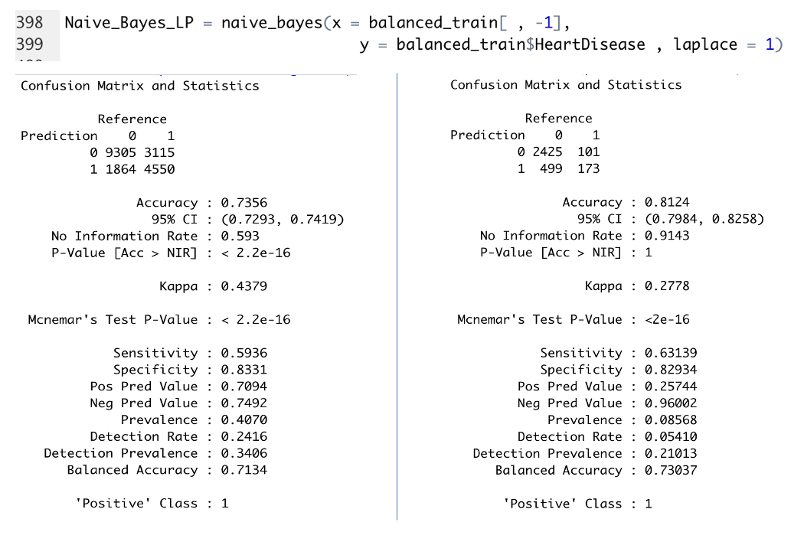

Figure : NB_lp evaluation metrics for (Left) Training set (Right) Test Set

From the figure above, using naïve bayes with Laplace = 1, the balanced accuracy between training and test set is 0.7134 and 0.73037 indicating good fit. The Kappa value of the test set is also fair at 0.2778 with sensitivity of 0.63139 and specificity of 0.82934. From the test set confusion matrix, the model can correctly classify more than half of the minority indicating that the synthesis minority class in the training set is able to train the model to perform well in classifying minority classes in an unbalanced dataset. The evaluation metrics is same with that out NB_basic.

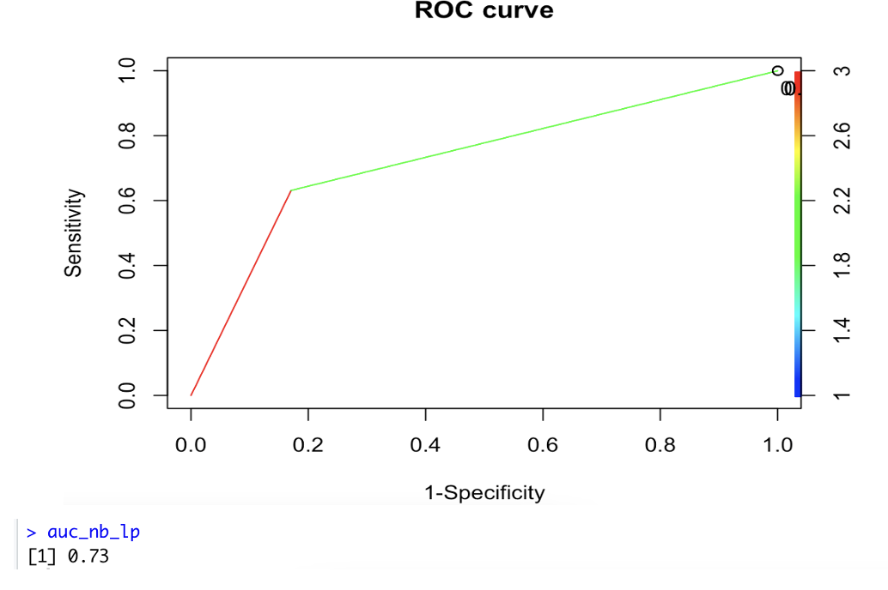

Figure : ROC - AUC for NB_lp

From the figure above, NB_lp model’s ROC curve indicates the model has high probability in classifying both classes correctly such that it would be significantly above a random classifier. In being able to distiguish between patients with and without heart disease, the AUC is at 0.73 which is fair. The ROC and AUC is same for that of NB_basic.

### 6.3.3 NB Laplace Smoothing with KDE (NB_KDE)

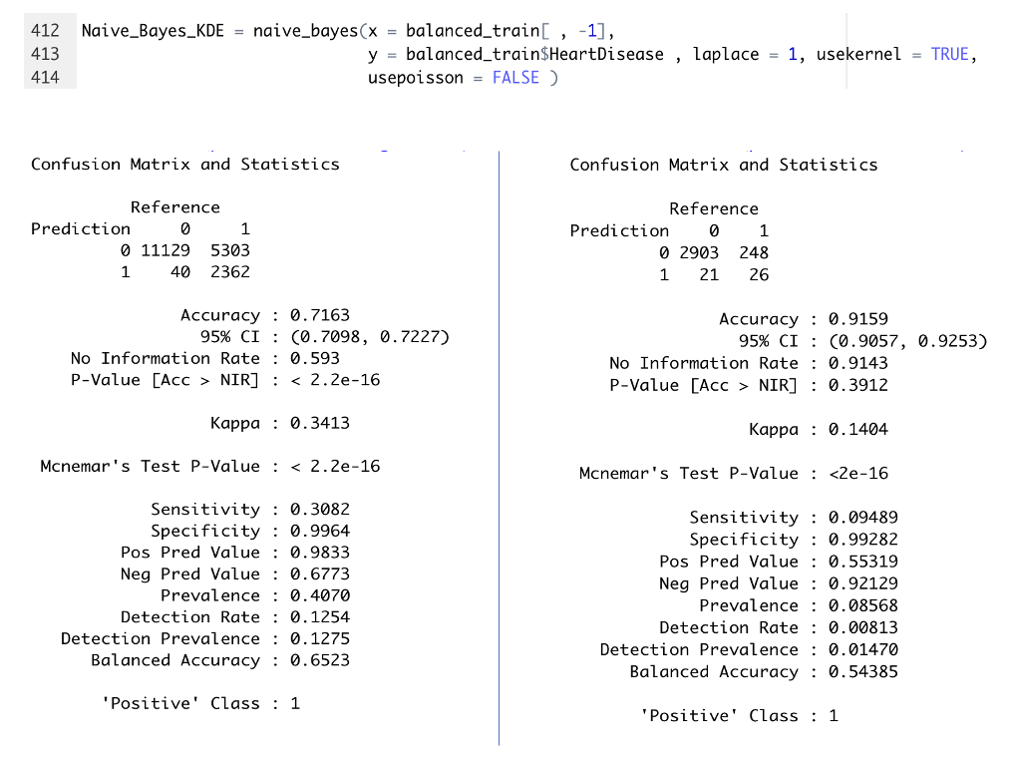

Figure : NB_KDE evaluation metrics for (Left) Training set (Right) Test Set

From the figure above, using naïve bayes Laplace = 1 with KDE, the balanced accuracy between training and test set is 0.6523 and 0.54385 indicating mediocre fit. The Kappa value of the test set is also poor at 0.1404 with sensitivity of 0.09489 and specificity of 0.99282. From the test set confusion matrix, the model is not able correctly classify most of the minority indicating that by applying KDE, the model becomes biased towards the majority class only as in both training and test set, it classifies the majority class well. Applying KDE significantly hampers the performance of the model.

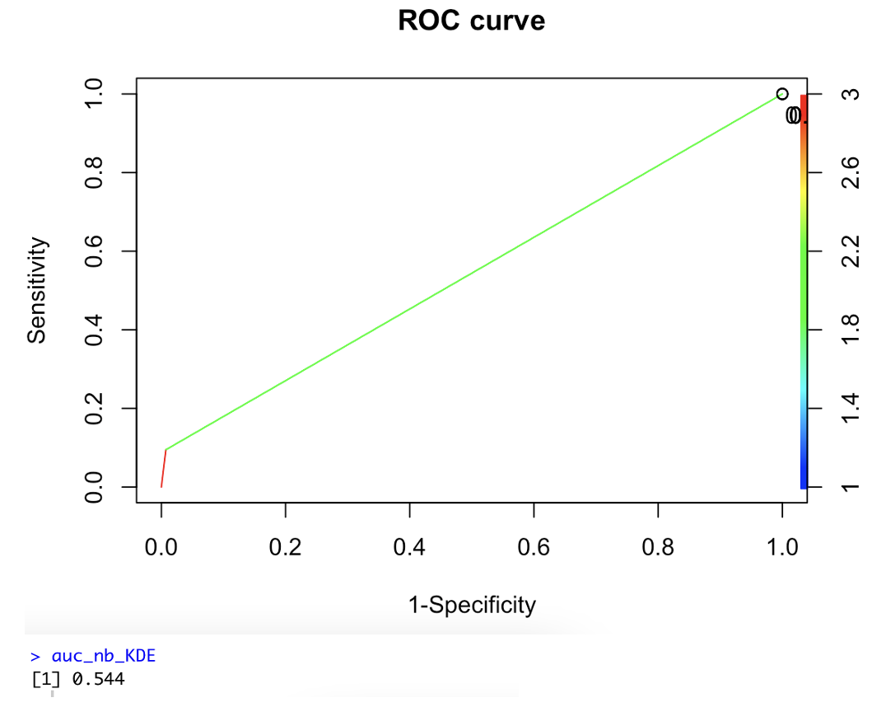

Figure : ROC - AUC for NB_KDE

From the figure above, NB_KDE model’s ROC curve indicates the model has mediocre probability in classifying both classes correctly such that it would be approximately at the same as a random classifier. In being able to distiguish between patients with and without heart disease, the AUC is at 0.544 which is considered fail.

### 6.3.4 NB Laplace Smoothing with POISSON (NB_PS)

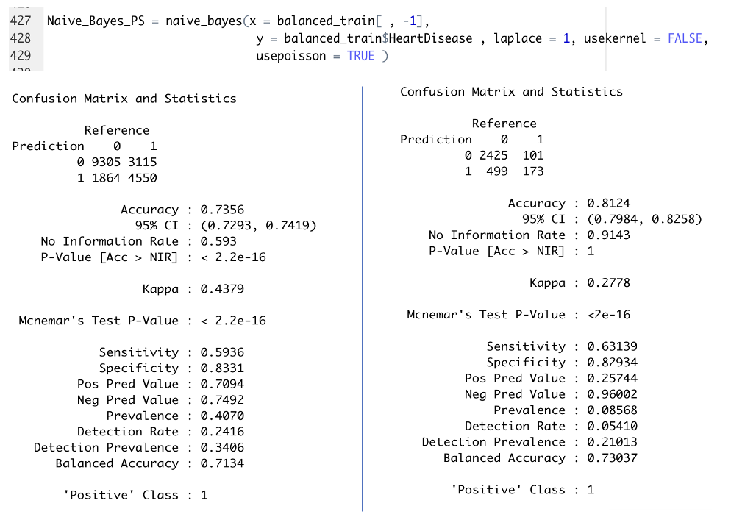

Figure : NB_PS evaluation metrics for (Left) Training set (Right) Test Set

From the figure above, using naïve bayes with Poisson, the balanced accuracy between training and test set is 0.7134 and 0.73037 indicating good fit. The Kappa value of the test set is also fair at 0.2778 with sensitivity of 0.63139 and specificity of 0.82934. From the test set confusion matrix, the model can correctly classify more than half of the minority indicating that the synthesized minority class in the training set is able to train the model to perform well in classifying minority classes in an unbalanced dataset. The evaluation metrics is same with that out NB_basic and NB_lp.

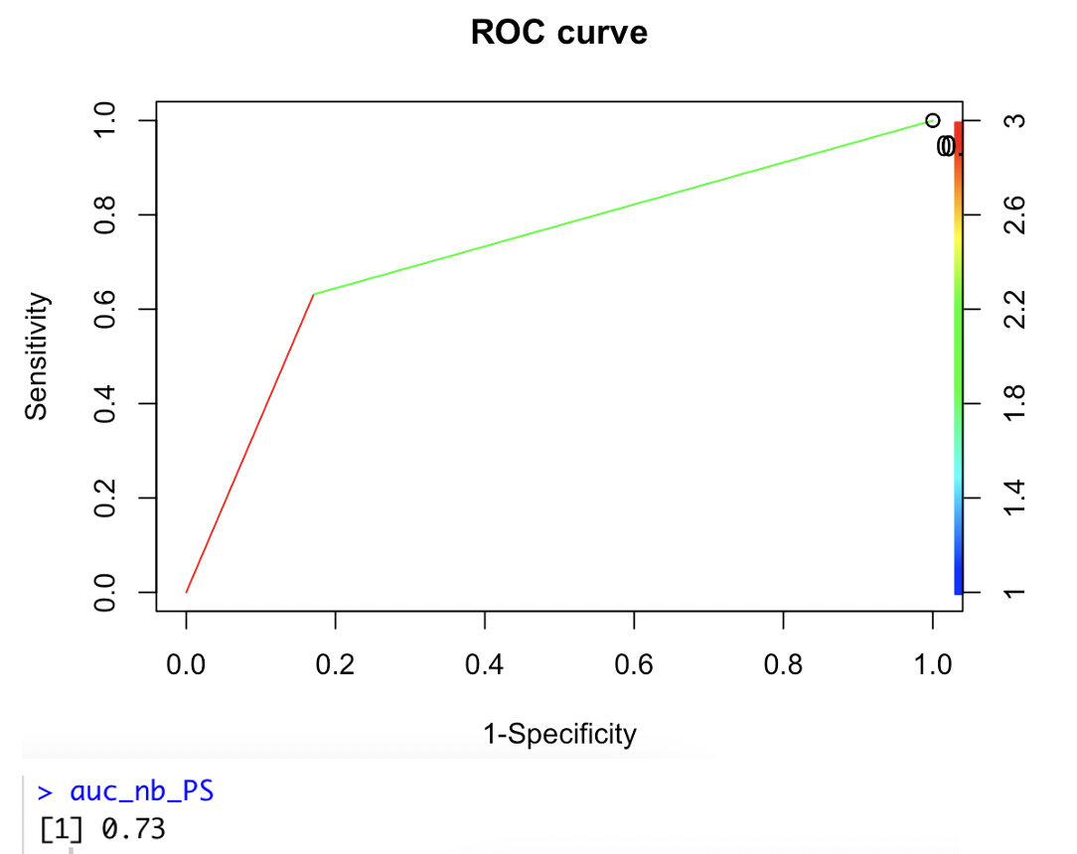

Figure : ROC - AUC for NB_PS

From the figure above, NB_PS model’s ROC curve indicates the model has high probability in classifying both classes correctly such that it would be significantly above a random classifier. In being able to distiguish between patients with and without heart disease, the AUC is at 0.73 which is fair. The ROC and AUC is same for that of NB_basic and NB_lp.

### 6.3.5 NB Laplace Smoothing with KDE and POISSON (NB_KDE_PS)

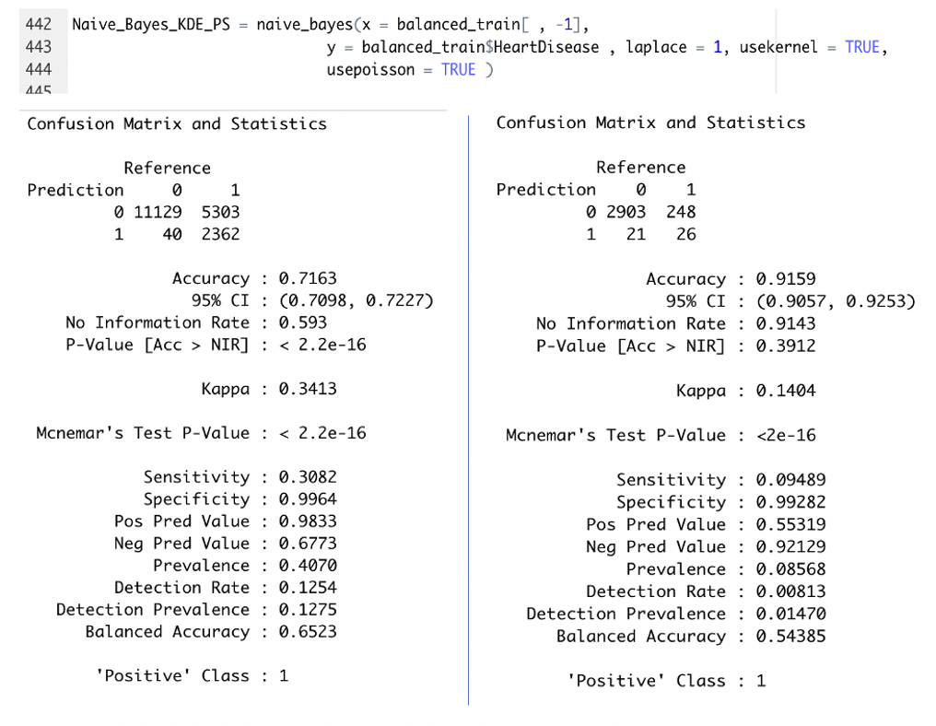

Figure : NB_KDE_PS evaluation metrics for (Left) Training set (Right) Test Set

From the figure above, using naïve bayes Laplace = 1 with KDE and PS, the balanced accuracy between training and test set is 0.6523 and 0.54385 indicating mediocre fit. The Kappa value of the test set is also poor at 0.1404 with sensitivity of 0.09489 and specificity of 0.99282. From the test set confusion matrix, the model is not able correctly classify most of the minority indicating similar to that of NB_KDE. The model becomes biased towards the majority class since in both training and test set, it classifies the majority class well but minority class poorly. Since applying PS results in a good model performance such as in NB_PS, it can be concluded that by applying KDE such as in NB_KDE, it would negatively impact Naïve Bayes model’s performance in this study.

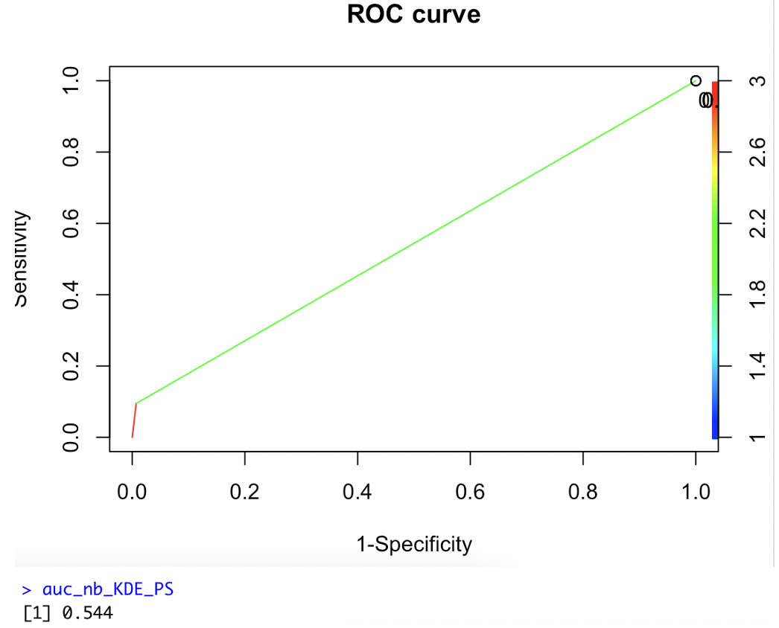

Figure : ROC - AUC for NB_KDE_PS

From the figure above, NB_KDE_PS model’s ROC curve indicates the model has mediocre probability in classifying both classes correctly such that it would be approximately at the same as a random classifier. In being able to distiguish between patients with and without heart disease, the AUC is at 0.544 which is considered fail.

### 6.3.6 Tuned Naïve Bayes (NB_tuned)

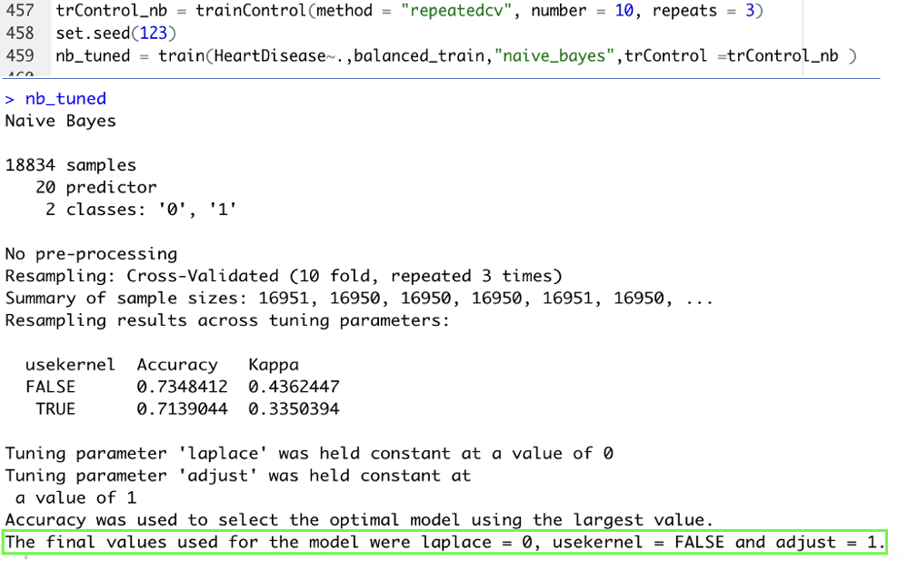

Figure : Tuning NB model with Cross Validation technique

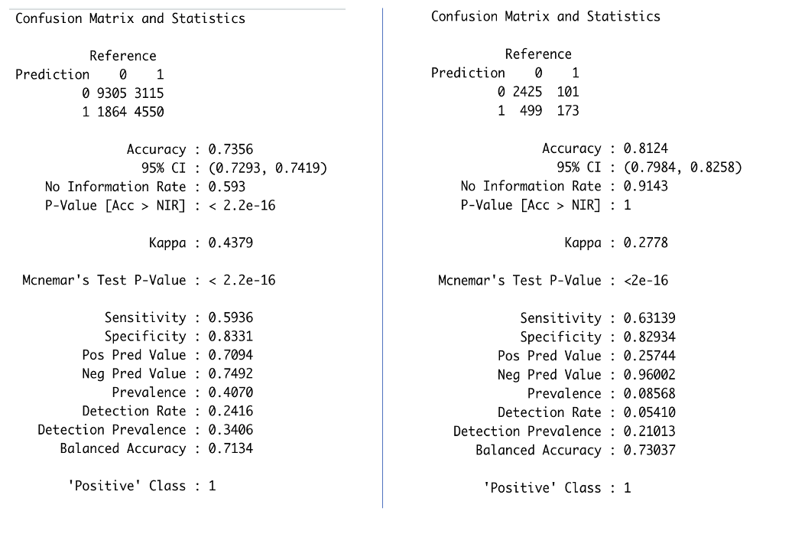

Figure : NB_Tuned evaluation metrics for (Left) Training set (Right) Test Set

From the figure above, by tunning a naïve bayes model using 10-fold cross validation with 3 times repeat, the balanced accuracy between training and test set is 0.7134 and 0.73037 indicating good fit. The Kappa value of the test set is also fair at 0.2778 with sensitivity of 0.63139 and specificity of 0.82934. From the test set confusion matrix, the model can correctly classify more than half of the minority indicating that the synthesized minority class in the training set is able to train the model to perform well in classifying minority classes in an unbalanced dataset. The evaluation metrics is same with that out NB_basic, NB_lp and NB_PS.

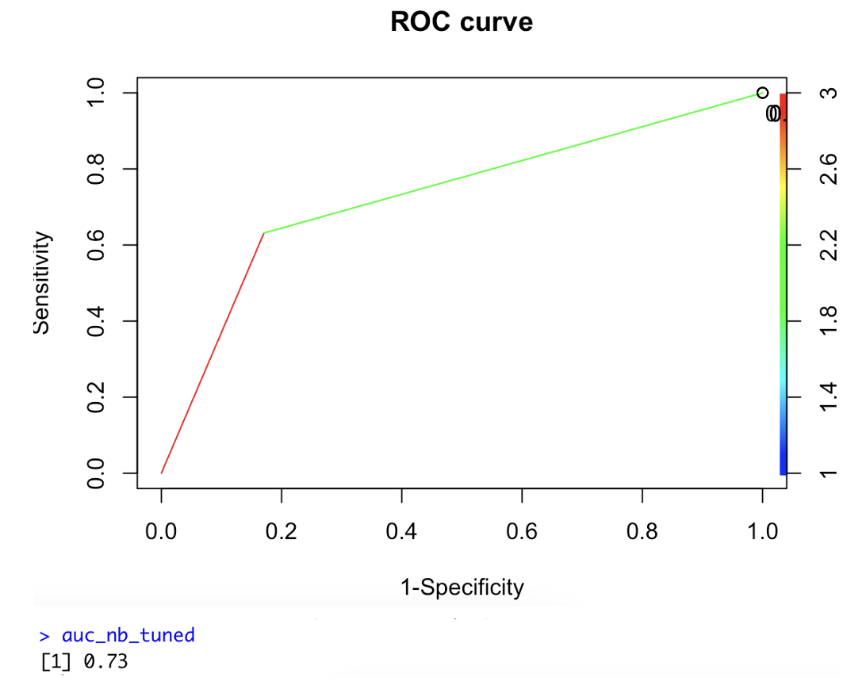

Figure : ROC - AUC for NB_Tuned

From the figure above, NB_Tuned model’s ROC curve indicates the model has high probability in classifying both classes correctly such that it would be significantly above a random classifier. In being able to distiguish between patients with and without heart disease, the AUC is at 0.73 which is fair. The ROC and AUC is same for that of NB_basic, NB_lp and NB_PS.

### 6.3.7 Comparison of NB models

Table : Comparison of each NB model's performance



Comparing the performance of each model against each other, it can be seen from the table above that by applying Kernel Density Estimate, the model is significantly hampered in its performance. The usekernel = TRUE parameter enforces kernel density to be applied to numeric features across the distribution. As the dataset used in modelling is encoded, all features are converted to numeric, hence this estimate is applied across all features. The fluctuating surface of KDE on this dataset specifically the base continuous variables would cause high distortion in its computations. As seen in EDA, the distributions are hardly gaussian hence assuming KDE would negatively impact model performance as seen in NB_KDE and NB_KDE_PS. Other than that, Naïve Bayes Model with and without Laplace generated same results. This is also seen across in model with Poisson applied. In tuning the naïve bayes model, 10 fold cross validation with a repeat of 3 is used . Method is set to naïve bayes such that parameters laplace, usekernel and adjust is tuned. The tuned model produced the same output is models without kernel density estimate. The best model is taken as NB_tuned .

## 6.4 Support Vector Machines (SVM)

### 6.4.1 SVM with RBF kernel (SVM_RBF)

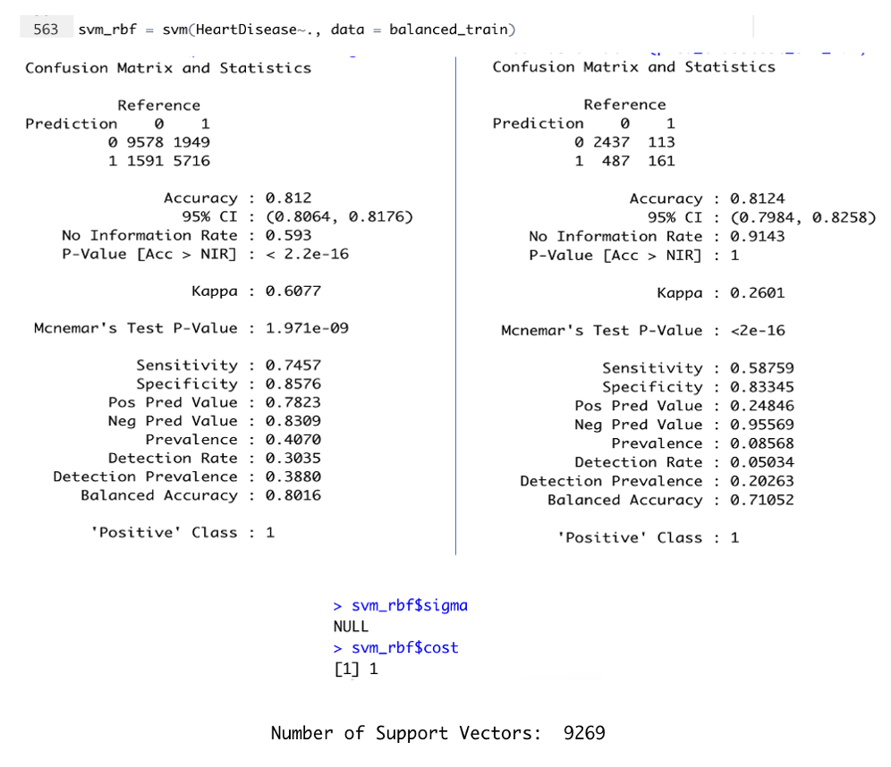

Figure : SVM_RBF evaluation metrics for (Left) Training set (Right) Test Set

From the figure above, using SVM default mode, RBF kernel, the balanced accuracy between training and test set is 0.8016 and 0.71052 indicating good fit. The Kappa value of the test set is also fair at 0.2601 with sensitivity of 0.58759 and specificity of 0.83345. From the test set confusion matrix, the model can correctly classify slightly more than half of the minority class indicating that the synthesized minority class in the training set is reasonably fair in training the model to perform classification of minority classes in an unbalanced dataset. For the sigma and cost parameters, default values of Null and 1 is chosen by the model. The model uses a total of 9269 support vectors.

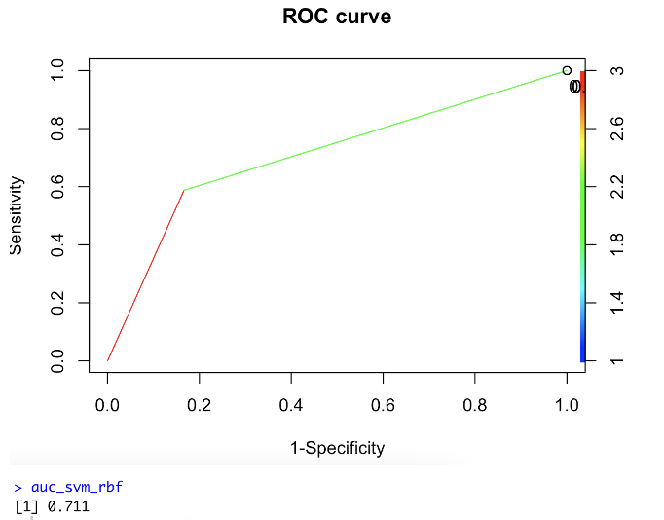

Figure : ROC - AUC for SVM_RBF

From the figure above, SVM_RBF model’s ROC curve indicates the model has high probability in classifying both classes correctly such that it would be above a random classifier. In being able to distiguish between patients with and without heart disease, the AUC is at 0.711 which is fair.

### 6.4.2 SVM with Linear kernel (SVM_LN)

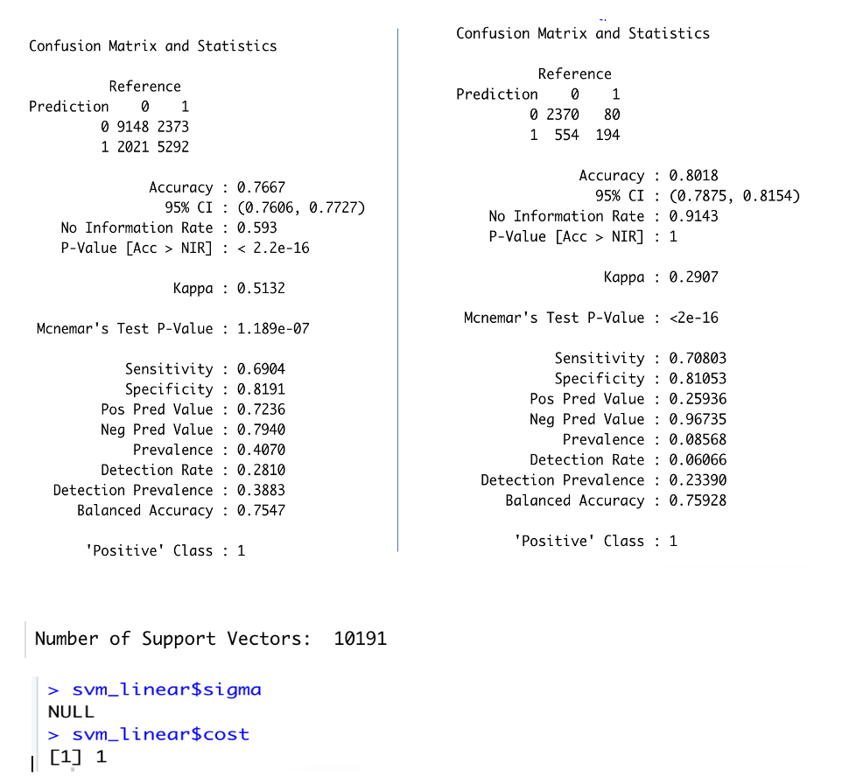

Figure : SVM_LN evaluation metrics for (Left) Training set (Right) Test Set

From the figure above, using SVM with linear kernel, the results from both training and test for balanced accuracy is 0.7547 and 0.75928 indicating good fit. The Kappa value of the test set is also fair at 0.2907 with sensitivity of 0.70803 and specificity of 0.81053. From the test set confusion matrix, the model can correctly classify more than half of the minority class indicating that the synthesized minority class in the training set is reasonably fair in training the model to perform classification of minority classes in an unbalanced dataset. For the sigma and cost parameters, default values of Null and 1 is chosen by the model. The model uses a total of 10191 support vectors.

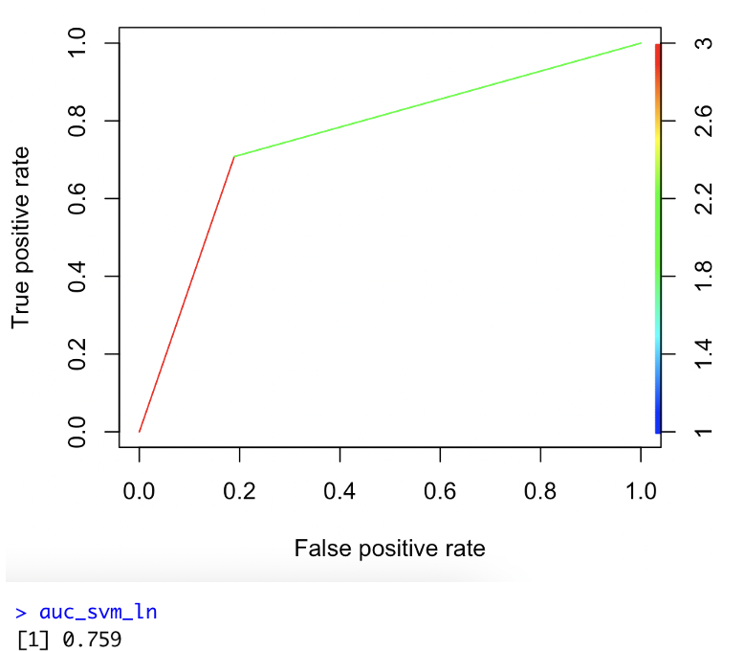

Figure : ROC - AUC for SVM_LN

From the figure above, SVM_LN model’s ROC curve indicates the model has high probability in classifying both classes correctly such that it would be above a random classifier. In being able to distiguish between patients with and without heart disease, the AUC is at 0.759 which is fair. The ROC and AUC is higher than that of SVM_RBF.

### 6.4.3 SVM with Sigmoid kernel (SVM_SG)

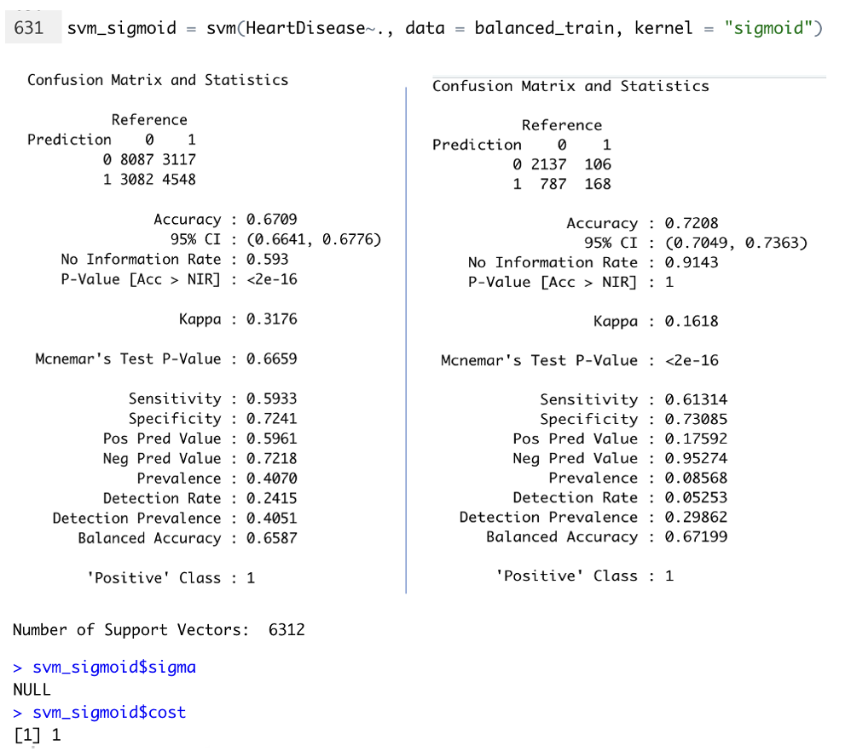

Figure : SVM_RBF evaluation metrics for (Left) Training set (Right) Test Set

From the figure above, using SVM, sigmoid kernel, the balanced accuracy between training and test set is 0.6587 and 0.67199 indicating good fit. The Kappa value of the test set is poor at 0.1681 with sensitivity of 0.61314 and specificity of 0.67199. From the test set confusion matrix, the model can correctly classify more than half of the minority class indicating that the synthesized minority class in the training set is reasonably fair in training the model to perform classification of minority classes in an unbalanced dataset. For the sigma and cost parameters, default values of Null and 1 is chosen by the model. The model also uses a total of 6312 support vectors.

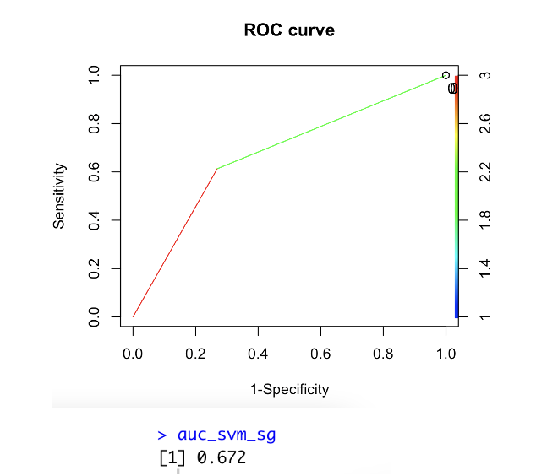

Figure : ROC - AUC for SVM_SG

From the figure above, SVM_SG model’s ROC curve indicates the model has low probability in classifying both classes correctly although it would still be above a random classifier. In being able to distiguish between patients with and without heart disease, the AUC is at 0.672 which is fair.

### 6.4.4 Tuned SVM (Tuned_SVM)

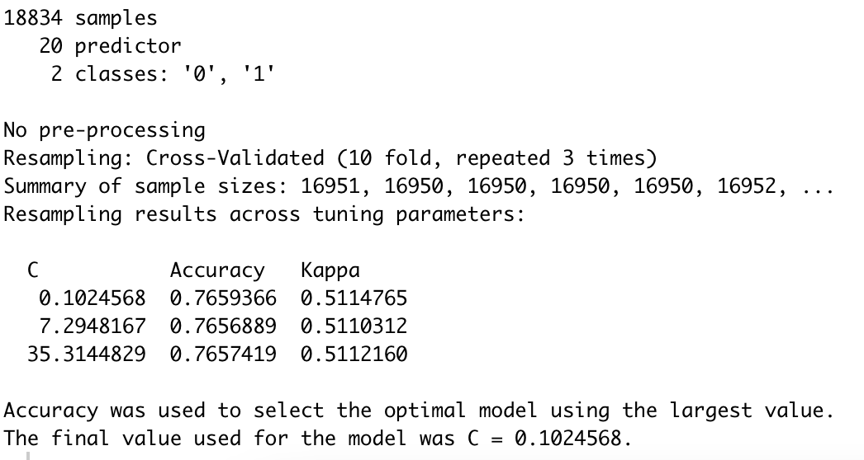

Figure : Tuning SVM model with Cross Validation technique

As linear kernel produces the best performing untuned SVM model, using svmLinear, hyperparameter C is ran through the train function with random search strategy using 10-fold cross validation on repeat of 3. The parameter C, manages the degree of correct classification by controlling a trade-off between smooth decision boundary and correctly classifying training points. In this tuned model, the final values with highest accuracy determined by random search for C is 0.1024568.

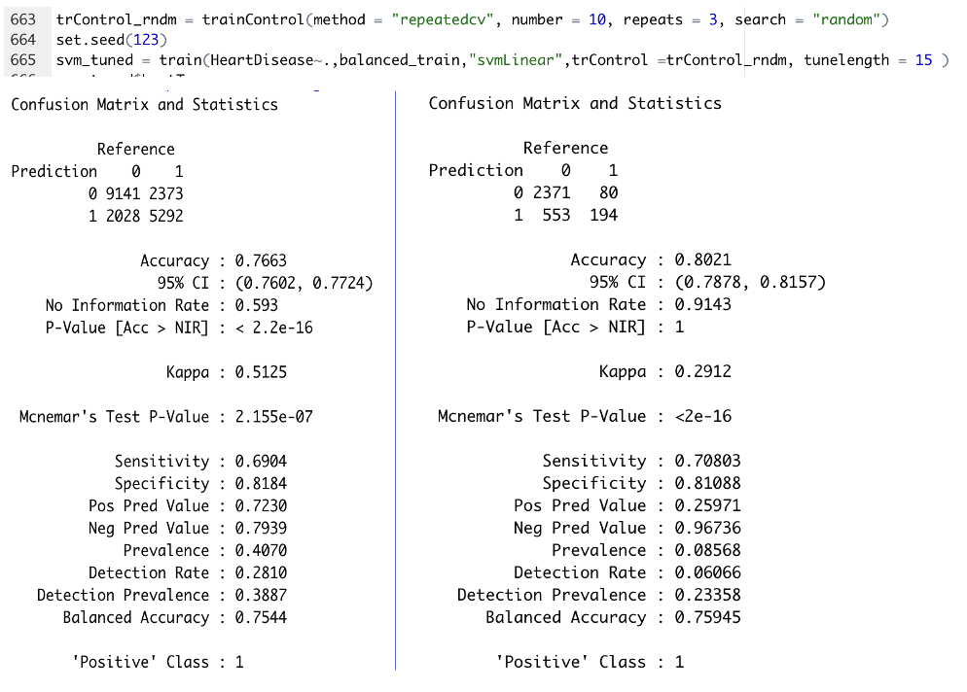

Figure :Tuned_SVM evaluation metrics for (Left) Training set (Right) Test Set

From the figure above, tuned SVM results from both training and test set is slightly better than untuned SVM with linear kernel. The balanced accuracy between training and test set is 0.7544 and 0.75945 indicating good fit. The Kappa value of the test set is fair at 0.2912, slightly better than untuned methods. The tuned model also produced sensitivity of 0.70803 and specificity of 0.81088 across the test set. From the test set confusion matrix, the model can correctly classify more than half of the minority class indicating that the synthesized minority class in the training set is good in training the model to perform classification of minority classes in an unbalanced dataset.

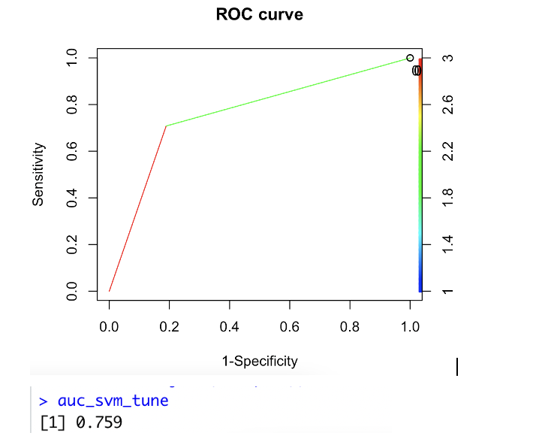

Figure : ROC - AUC for Tuned_SVM

From the figure above, SVM_tuned model’s ROC curve indicates the model has high probability in classifying both classes correctly such that it would be above a random classifier. In being able to distiguish between patients with and without heart disease, the AUC is at 0.759 which is fair. The ROC and AUC is better than that of untuned methods.

### 6.4.5 Comparison of SVM models

Table : Comparison of each SVM model's performance



Table above captures the comparison of all SVM models built. From the comparison table it can be seen that by using various kernels, the results obtained across training and test set varies slightly. For untuned SVM, the best performing model was obtained using linear kernel indicating that the dataset is linearly separable. With the linear kernel as a base, the model is tuned further to obtain the best hyperparameter value for the method “svmLinear”. It was found the best value for C is 0.1024568. Using the tuned model, the balanced accuracy for test set improved compared to the other SVM models. Sensitivity of the tuned model increase slightly allowing for the model to classify the minority class better in the unbalanced test set. Although there is a large different in Kappa value between training and test in Tuned_SVM, this is due to the nature of the datasets. Training set was balanced with synthesized sample while test set was an unbalanced dataset with only true values. Overall Tuned_SVM was the best model for SVM.

## 6.5 Decision Tree (DT)

### 6.5.1 DT_Gini

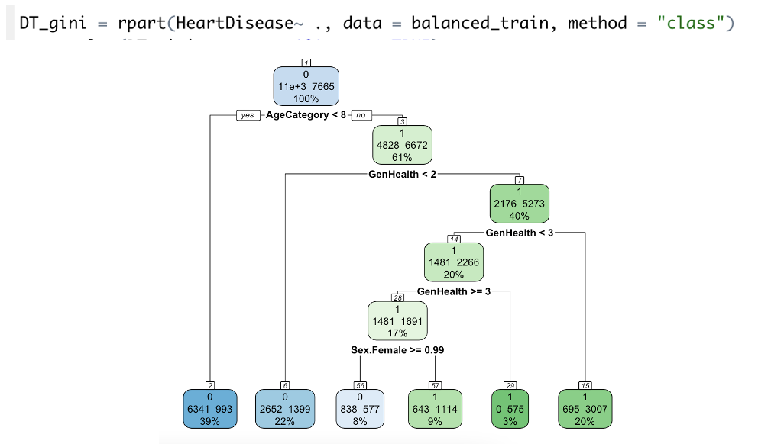

Figure : rpart.plot for DT_Gini

Figure above shows the decision tree plot for DT_Gini. It can be seen that the purity in leaf nodes are not ideal. The splits too do not branch out to many branches due to low tree depth.

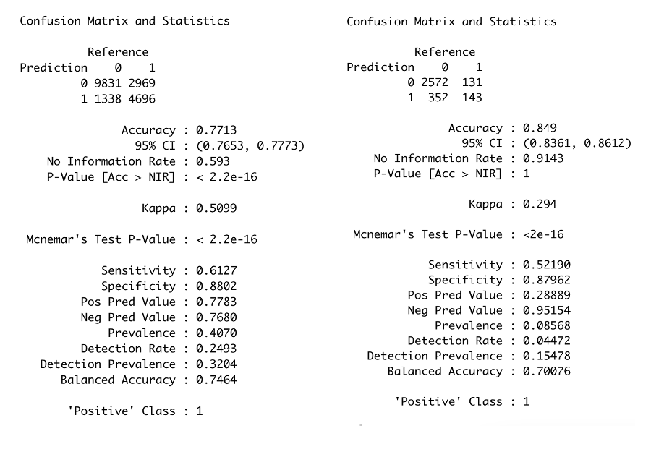

Figure : DT_Gini evaluation metrics for (Left) Training set (Right) Test Set

From the figure above of DT Gini’s confusion matrix, the balanced accuracy between training and test set is 0.7464 and 0.70076 indicating good fit. The Kappa value of the test set is fair at 0.294. The model also produced sensitivity of 0.52190 and specificity of 0.87962 across the test set. From the test set confusion matrix, the model can correctly barely classify more than half of the minority class indicating that the synthesized minority class in the training set is fair in training the model to perform classification of minority classes in an unbalanced dataset.

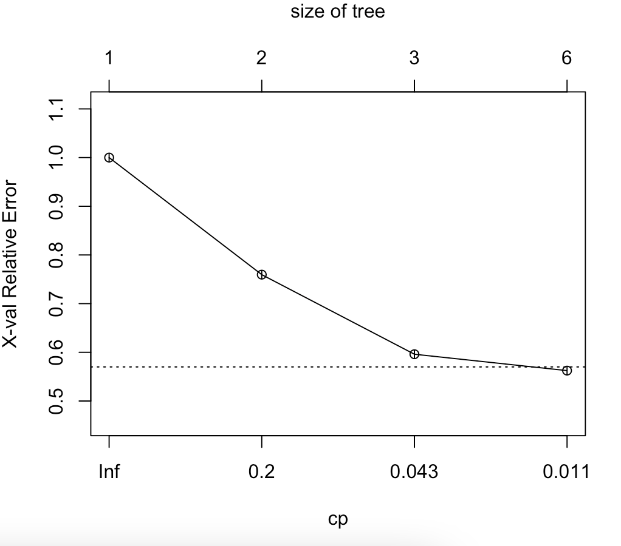

Figure : CP plot of DT_Gini

For CP plot, the size of tree at 6 brings the error level between 0.5 and 0.6 but doesn’t show signs of tapering down. More trees could be introduced to reduce the relative error. Tree building should continue as the overall fit is not optimized.

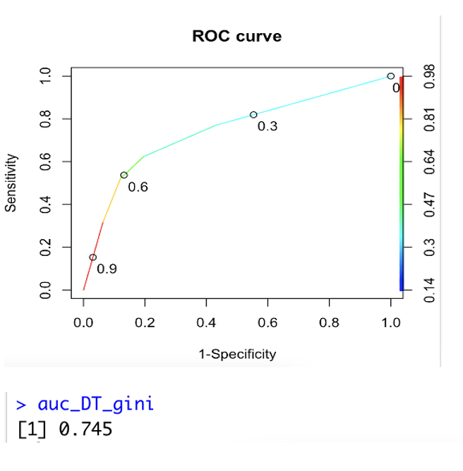

Figure : ROC - AUC for DT_gini

From the figure above, DT_gini model’s ROC curve indicates the model has high probability in classifying both classes correctly such that it would be above a random classifier. In being able to distiguish between patients with and without heart disease, the AUC is at 0.745 which is fair. The ROC and AUC is slightly better than models of other algorithms.

### 6.5.2 DT_Ent

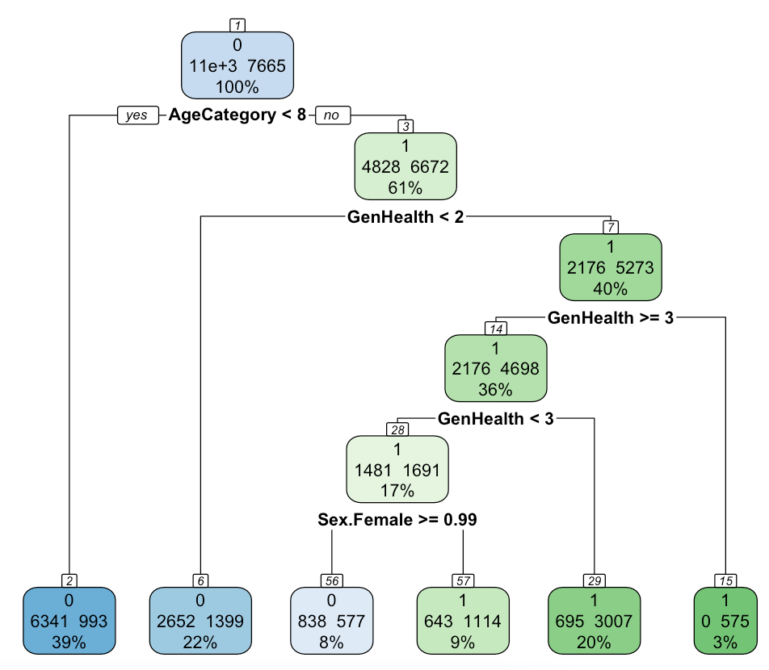

Figure : rpart.plot for DT_Ent

Figure above shows the decision tree plot for DT_Ent. The tree plot is exactly the same as that of DT_Gini. It can be seen that the purity in leaf nodes are not ideal. The splits too do not branch out to many branches due to low tree depth.



Figure : DT_Ent evaluation metrics for (Left) Training set (Right) Test Set

From the figure above of DT_Ent’s confusion matrix, the values obtain is same for that of DT_Gini. The balanced accuracy between training and test set is 0.7464 and 0.70076 indicating good fit. The Kappa value of the test set is fair at 0.294. The model also produced sensitivity of 0.52190 and specificity of 0.87962 across the test set. From the test set confusion matrix, the model can barely classify more than half of the minority class indicating that the synthesized minority class in the training set is fair in training the model to perform classification of minority classes in an unbalanced dataset.

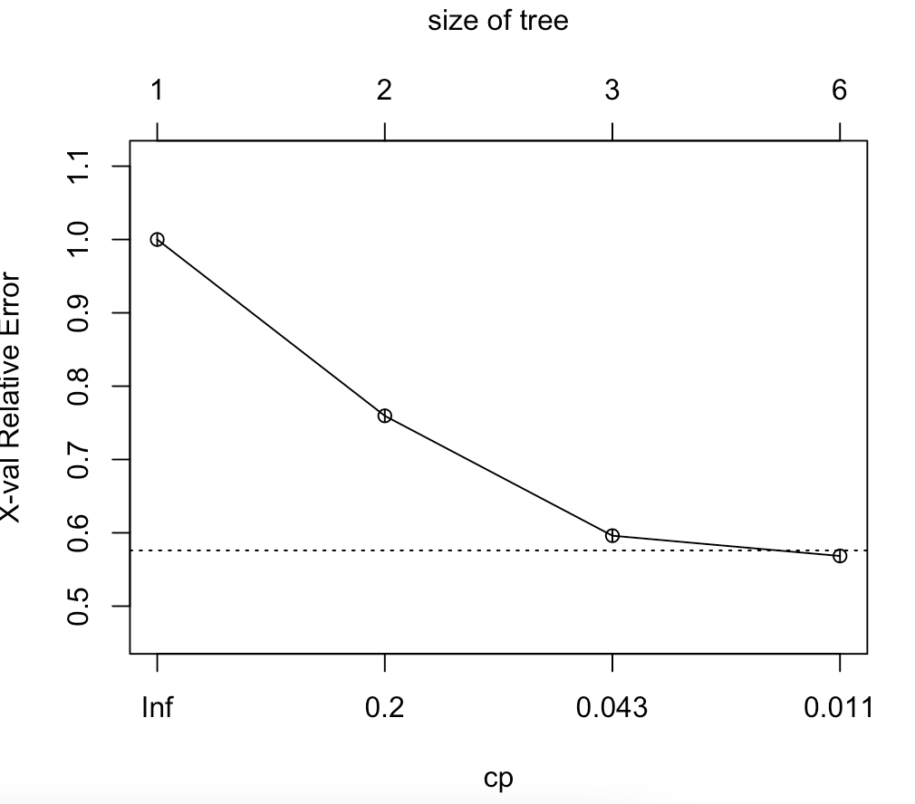

Figure : CP plot of DT_Ent

For CP plot, observations are same with that of DT_Gini. The size of tree at 6 brings the error level between 0.5 and 0.6 but doesn’t show signs of tapering down. More trees could be introduced to reduce the relative error. Tree building should continue as the overall fit is not optimized.

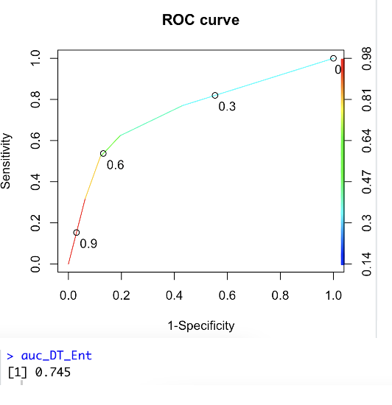

Figure : ROC - AUC for DT_Ent

From the figure above, DT_Ent model’s ROC curve indicates the model has high probability in classifying both classes correctly such that it would be above a random classifier. In being able to distiguish between patients with and without heart disease, the AUC is at 0.745 which is fair. The ROC and AUC value is same with that of DT with Gini split.

### 6.5.3 DT_Tuned

Tuning of DT models were done in two steps. The process started with tuning the CP value followed by tuning the max depth parameter. The tuning of both parameters were done using grid search hyperparameter tuning with 10 fold cross validation technique with repeat of 3. Initial default model with cross validation technique was built to gauge the range of CP and Max depth values for grid search.

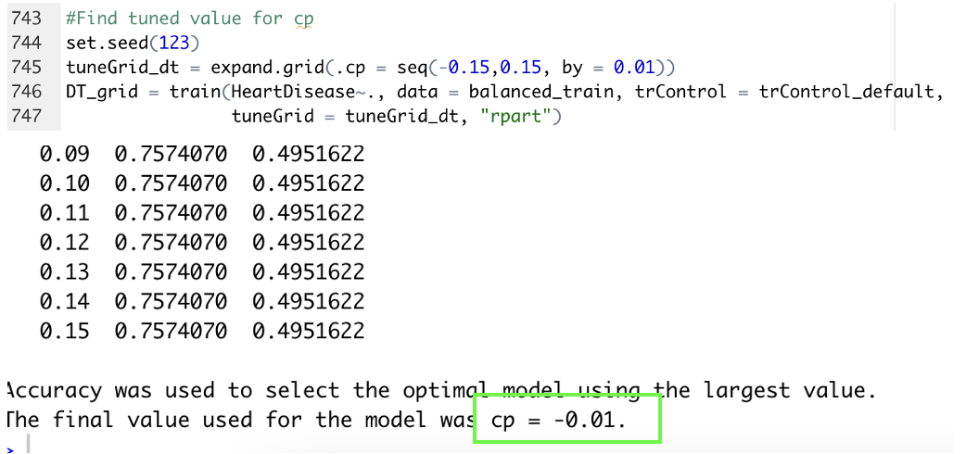

Figure : Tuning of CP value

Based on grid search tuning of CP value, the most optimal CP value was – 0.01. This CP value should enabled the built of a good size tree such that accuracy would improve as more observation are classified with higher details. Grid Search was set between -0.15 to 0.15 with a step of 0.01.

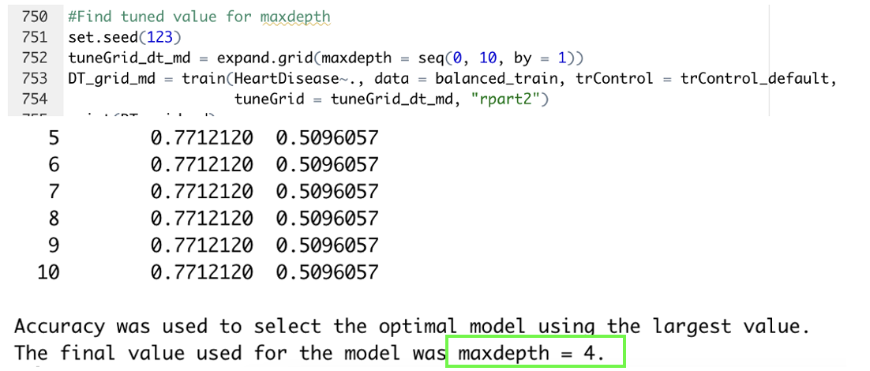

Figure : Tuning of maxdepth

Based on grid search tuning of maxdepth value as shown in figure above, the most optimal maxdepth value was 4. This parameter controls the maximum depth the tree created with reference to the length of the longest path from tree root to a leaf. Grid Search was set between 0 to 10 with a step of 1. Using both tuned CP and Maxdepth parameter, a DT model was built and evaluated using the same approach as other basic models.

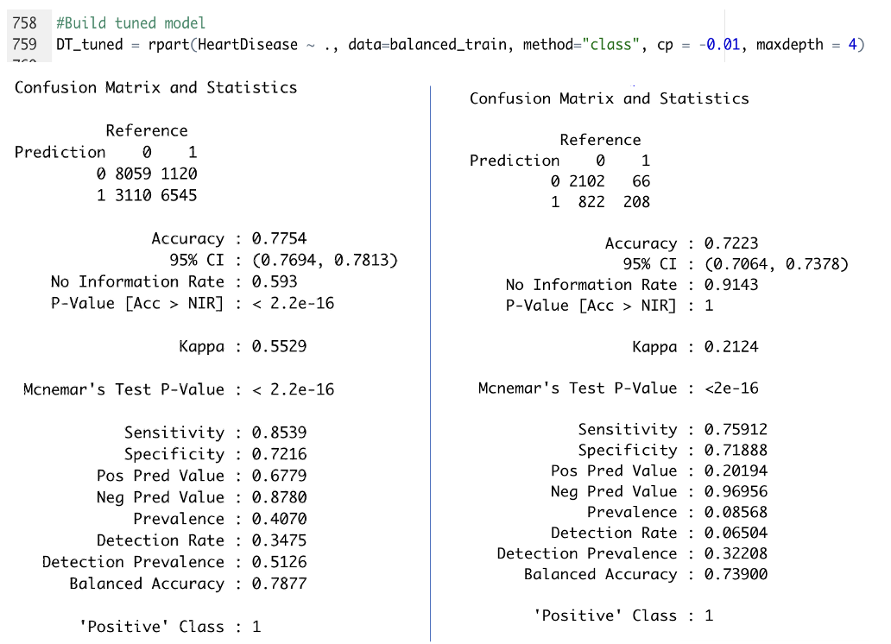

Figure : DT_Tuned evaluation metrics for (Left) Training set (Right) Test Set

From the figure above of DT_Tuned’s confusion matrix, the balanced accuracy between training and test set is 0.7877 and 0.73900 indicating good fit. The Kappa value of the test set is fair at 0.2124. The model also produced sensitivity of 0.75912 and specificity of 0.71888 across the test set. From the test set confusion matrix, the model can correctly classify more than half of the minority class indicating that the synthesized minority class in the training set is good in training the model to perform classification of minority classes in an unbalanced dataset.

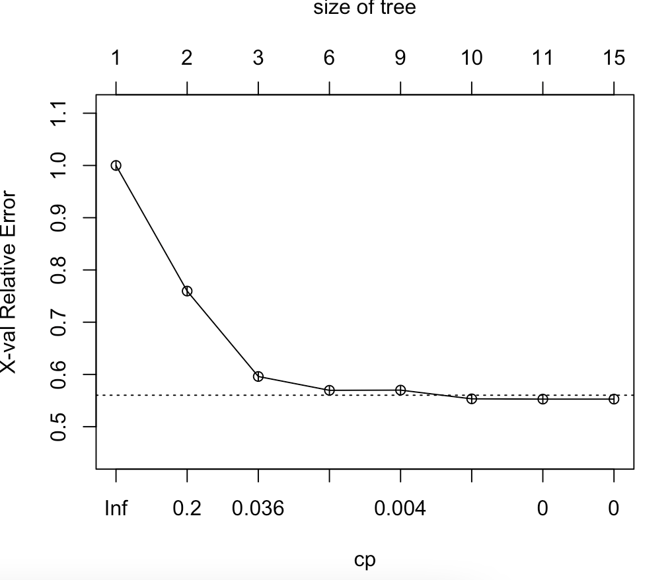

Figure : CP for Tuned_DT

For CP plot, observations is such that there is an increase in size of trees as compared to untuned methods. The size of tree at 14 brings the error level between 0.5 to 0.6 with the curve flattening out. This optimized tuned model allows for an improved balanced accuracy with good fit compared to untuned methods .

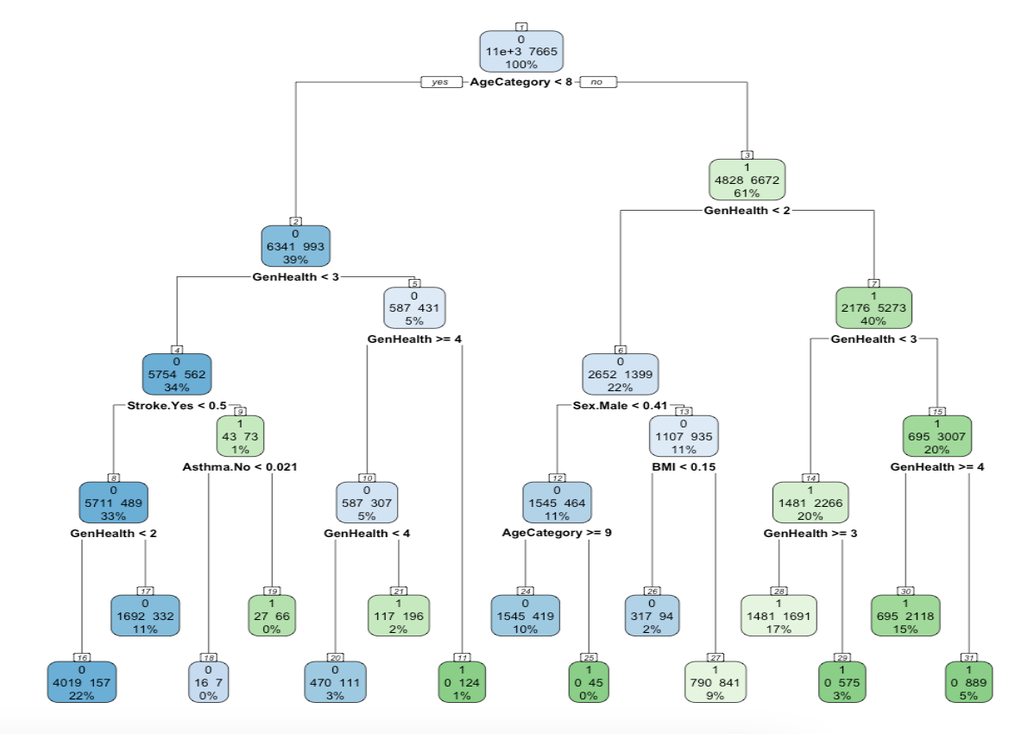

Figure : rpart.plot for DT_Tuned

Figure above shows the decision tree plot for DT_Tuned. The tree plot has more depth compared to that of the untuned methods with mode nodes branching to enabled detailed classification. The purity of leaf nodes has also significantly improved thus allowing for a improved balanced accuracy value.

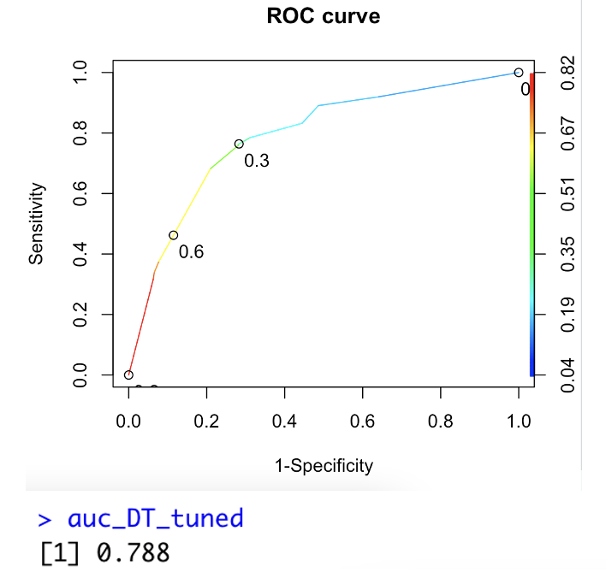

Figure : ROC - AUC for DT_Tuned

From the figure above, DT_Tuned model’s ROC curve indicates the model has high probability in classifying both classes correctly such that it would be above a random classifier. In being able to distiguish between patients with and without heart disease, the AUC is at 0.788 which is better than untuned methods.

6.5.4 Comparison of DT models

Table : Comparison Table of DT models

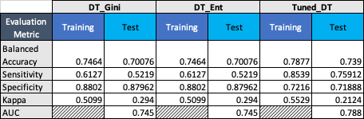

From the comparison in Table 6, gini split and entropy split does not bring about any difference in model’s results. The fit in both models is good with high possibility in accurately classifying the negative class (specificity). However it does not do to well in accurately classifying the positive class (sensitivity) which in this case would be the minority class. In the test set, it barely is able to classify half of the minority class such that the sensitivity in both these models is 0.5219. This low sensitivity value would require the model to be tuned to optimize its performance in classifying minority and majority class in the unbalanced test set. Tuning is done use two different methods to obtain best values of cp and maxdepth. Using the tuned parameters, models balanced accuracy was increase to 0.739. The main difference is the potential in classifying positive class (minority). Compared to sensitivity values of non-tuned DT models in test set, the sensitivity increased significant from 0.5219 to 0.75912. Hence, by tuning, the model is more reliable in classification of an unbalanced dataset. The AUC of the tuned model also increased to 0.788 compared to untuned methods. Hence the model has high probability in classifying both classes correctly.

# 7.0 ANALYSIS AND RECOMMENDATIONS

From the results obtained from various models, hyperparameter tuning help in optimizing the models for the dataset analysed. The models built on an balanced training set is able to perform relatively well with good fit on an unbalanced test set. The concept of only balancing the training set is such that in production level real-life scenario’s, unseen dataset are typically unbalanced. Hence this study explores the concept of training models on synthetically balanced dataset and evaluations of its performance on an unbalanced dataset. Table 7 below documents the evaluation metric values of the best model across each algorithm used.

Table : Comparison of best performing model of each algorithm



From the comparison table, the best performing model for this study is from tuned Support Vector Machines. The balanced accuracy from Tuned_SVM is 0.75945 which is slightly higher than other models. The Tuned_NB, Tuned_DT and LR models were close in performance as the balanced accuracy were all above 70%. However in terms of being able to accurately classify the minority class given an unbalanced scenario, tuned decision tree with cp of -0.01 and a maxdepth of 4, has the best performance with 0.75912 which is much higher compared to other models. The trade of here is that it has much lower specificity compared to other models. The decision tree model was trained well to have an approximately similar predictive capability across both major and minor classes as sensitivity and specificity are close in value. Kappa value in LR is the highest at 0.2923 compared to that of other models. All the best models of each algorithm have values of Kappa that would be classified as fair on the kappa scale. Other than that, AUC for LR is significantly higher compared to other models. Using LR, the model has a higher probability of performing a more accurate classification as compared to other models.

In Naive Bayes model, Laplace smoothing does not lead to any difference in evaluation outcome when compared to non – Laplace model. As such the probabilities generated from bayes theorem for this study does not generate any zero probability hence not requiring Laplace smoothing. In addition to that, by applying kernel, the models perform significantly worst as the developed model would only be able to classify the majority class with almost no ability to classify the minority class. In SVM however, using kernel transformations generates significantly different results across RBF, Linear and Sigmoid based models. By applying linear kernelization the model is able to obtain the best evaluation results for SVM. This comparisons of kernels illustrates that the dataset used is linearly separable such that the algorithm is able to find a straight line to maximize the margins to the closest point to it. The linear based SVM is further enhanced by tuning the model using method “SVMlinear” with random search in the tune function. With 10 fold cross validation of 3 times repeat, the cost value was determined to be 0.1024568. Using this value slightly improved the balanced accuracy of the model on the test set. Similar approach was used in tuning the decision tree model, however grid search was used as the tuning strategy. Table 8 below compares the developed models in this study against peer findings.

Table : Comparison with Peer study



Based on the comparison above, it can be seen that the models developed were at the lower range of the results obtain by peers. However this is due to several distinct methods used as part of research methodology. For one, this study adopts the concept of training developed model using SMOTE based balanced dataset followed by testing on an unbalanced dataset. In peer reviewed work, the top performing models majority did not perform data balancing as the dataset is either is balanced or unbalanced dataset was used. In Mahmoud et al. (2021), Framingham dataset was used in its original form containing imbalanced data that would skew the evaluation metrics. Other studies such as in Gupta et al.(2022), Garate-Escamila et al.(2020), and Almustafa (2020), dataset used did not require balancing hence heart disease prediction models would be relatively better performing compared to an unbalanced dataset. In addition to that, peers findings did also incorporate different techniques in balancing their dataset. Sowjanya and Mrudula (2022), found that by using Bi-phasic SMOTE, predictive models built on the artificially balanced dataset presents significantly better results compared to using standard SMOTE technique. On the hand Fitriyani et al. (2020) found that by using SMOTE-ENN, extension to standard SMOTE, the accuracy of testing developed models also improved compared to basic SMOTE technique.

The other distinctive method is the approach in feature selection used. This study uses BORUTA technique which is based of random forest for selecting features by comparison importance score of each value with each other. One of the better performing research, Almustafa (2020), discuss the usage of classifier subset evaluator as a feature extraction method that allowed for higher accuracy in model prediction. In another study by Garate-Escamila et al.(2020), feature selection using a combination of CHI-PCA allowed for higher performing models compared to using complete features or CHI as a feature selection technique. This variation in feature selection techniques could contribute significantly the difference in model performances.

For future recommendation, one could experiment with different types of data balancing techniques and compare it with SMOTE as a reference. Modifying existing SMOTE algorithm can such as that in Sowjanya and Mrudula (2022) and Fitriyani et al. (2020) could also be explored. In addition to that, it is recommended to also experiment on upsampling the minority class to fit the majority class of the original dataset with 320K observations. Although using this method, models such as SVM and BORUTA would be computational infeasible with a basic machine, one can approach this dataset using different feature selection techniques. Exploration of more complex non-linear models could also improve overall model accuracy when coupled with strong feature selection methods.

# 8.0 CONCLUSION

In conclusion, heart disease predictive models are crucial for the healthcare sector. With the rising cases and complexity in diagnosing heart disease, predictive mode can not only improve overall early detection method, it can also efficient prognosis. In developing machine learning models as part of this study, data balancing is a challenge in any dataset specifically in healthcare. As machine learning model learn from historical data to improve its predictive capability, imbalance dataset can skew the learning process significant hence novel balancing techniques are required. SMOTE provides strong capabilities in balancing the dataset, however synthesized instances can fail to replicate the characteristics of actual datapoints. The algorithm would need to be explore further in order to further understand its parameters to tailor it according to the given dataset. Apart from that, machine learning model perform very distinctively from each other. Tuning models are imperative in obtaining the best performing model for an algorithm.

# REFERENCES

Aijaz, B., & Bittner, V. (2014). Coronary heart disease: Risk factors. *Manual of Coronary Heart Diseases*, 1–1. https://doi.org/10.5005/jp/books/12337_1

Alalawi, H., & Alsuwat, M. (2021). Detection of Cardiovascular Disease using Machine Learning Classification Models. *International Journal of Engineering Research & Technology*, *10*(7), 151–157.

Almustafa, K. M. (2020). Prediction of heart disease and classifiers’ sensitivity analysis. *BMC Bioinformatics*, *21*(1). https://doi.org/10.1186/s12859-020-03626-y

Bektas, J., Ibrikci, T., & Ozcan, I. T. (2017). Classification of real imbalanced cardiovascular data using feature selection and sampling methods: A case study with neural networks and logistic regression. *International Journal on Artificial Intelligence Tools*, *26*(06), 1750019. https://doi.org/10.1142/s0218213017500191

Biglu, M.-H., Ghavami, M., & Biglu, S. (2016). Cardiovascular diseases in the Mirror of Science. *Journal of Cardiovascular and Thoracic Research*, *8*(4), 158–163. https://doi.org/10.15171/jcvtr.2016.32

Chao-Ying , P. J., Lee, K. L., & Ingersoll, G. M. (2020). An Introduction to Logistic Regression Analysis and Reporting. *The Journal of Educational Research*, *95*(1), 3–14. https://doi.org/https://doi.org/10.1080/00220670209598786

Chawla, N. V., Bowyer, K. W., Hall, L. O., & Kegelmeyer, W. P. (2002). Smote: Synthetic minority over-sampling technique. *Journal of Artificial Intelligence Research*, *16*, 321–357. https://doi.org/10.1613/jair.953

Dakka, M. A., Nguyen, T., Hall, J. M. M., Diakiw, S. M., VerMilyea, M., Linke, R., Perugini, M., & Perugini, D. (2021). Automated detection of poor-quality data: Case Studies in Healthcare. https://doi.org/10.21203/rs.3.rs-440365/v1

Domingos, P. (2012). A few useful things to know about machine learning. *Communications of the ACM*, *55*(10), 78–87. https://doi.org/10.1145/2347736.2347755

Dulhare, U. N. (2018). Prediction system for heart disease using naive Bayes and particle swarm optimization. *Biomedical Research*, *29*(12). https://doi.org/10.4066/biomedicalresearch.29-18-620

Durgesh, S., & Lekha, B. (2010). Data classification using Support Vector Machines. *Journal of Theoretical and Applied Information Technology*, *12*(1), 1–7.

Fernandez, A., Garcia, S., Herrera, F., & Chawla, N. V. (2018). Smote for learning from imbalanced data: Progress and challenges, marking the 15-year anniversary. *Journal of Artificial Intelligence Research*, *61*, 863–905. https://doi.org/10.1613/jair.1.11192

Fernández, A., García, S., Galar, M., Prati, R. C., Krawczyk, B., & Herrera, F. (2018). Learning from imbalanced data streams. *Learning from Imbalanced Data Sets*, 279–303. https://doi.org/10.1007/978-3-319-98074-4_11

Fitriyani, N. L., Syafrudin, M., Alfian, G., & Rhee, J. (2020). HDPM: An effective heart disease prediction model for a clinical decision support system. *IEEE Access*, *8*, 133034–133050. https://doi.org/10.1109/access.2020.3010511

Goel, R. (2021). Heart disease prediction using various algorithms of machine learning. *SSRN Electronic Journal*. https://doi.org/10.2139/ssrn.3884968

Gupta, C., Saha, A., Subba Reddy, N. V., & Dinesh Acharya, U. (2022). Cardiac disease prediction using supervised machine learning techniques. *Journal of Physics: Conference Series*, *2161*(1), 012013. https://doi.org/10.1088/1742-6596/2161/1/012013

Gárate-Escamila, A. K., Hajjam El Hassani, A., & Andrès, E. (2020). Classification models for heart disease prediction using feature selection and PCA. *Informatics in Medicine Unlocked*, *19*, 100330. https://doi.org/10.1016/j.imu.2020.100330

Hancock, H. C., Close, H., Fuat, A., Murphy, J. J., Hungin, A. P., & Mason, J. M. (2014). Barriers to accurate diagnosis and effective management of heart failure have not changed in the past 10 years: A qualitative study and national survey. *BMJ Open*, *4*(3). https://doi.org/10.1136/bmjopen-2013-003866

Hobbs, F. D. (2000). ABC of heart failure: Heart failure in general practice. *BMJ*, *320*(7235), 626–629. https://doi.org/10.1136/bmj.320.7235.626

Huffman, M. D., Rao, K. D., Pichon-Riviere, A., Zhao, D., Harikrishnan, S., Ramaiya, K., Ajay, V. S., Goenka, S., Calcagno, J. I., Caporale, J. E., Niu, S., Li, Y., Liu, J., Thankappan, K. R., Daivadanam, M., van Esch, J., Murphy, A., Moran, A. E., Gaziano, T. A., … Prabhakaran, D. (2011). A cross-sectional study of the microeconomic impact of cardiovascular disease hospitalization in four low- and middle-income countries. *PLoS ONE*, *6*(6). https://doi.org/10.1371/journal.pone.0020821

Kang, H. (2013). The prevention and handling of the missing data. *Korean Journal of Anesthesiology*, *64*(5), 402. https://doi.org/10.4097/kjae.2013.64.5.402

Katarya, R., & Srinivas, P. (2020). Predicting heart disease at early stages using Machine Learning: A Survey. *2020 International Conference on Electronics and Sustainable Communication Systems (ICESC)*. https://doi.org/10.1109/icesc48915.2020.9155586

Keogh, E. J., & Mueen, A. (2017). Curse of dimensionality. Encyclopedia of machine   
 learning and data mining, 2017, 314-315.

Lakshmanarao, A., Swathi, Y., & Sundareswar, S. (2020). Machine Learning Techniques For HeartDisease Prediction. *INTERNATIONAL JOURNAL OF SCIENTIFIC & TECHNOLOGY RESEARCH*, *8*(11).

Liu, S., Wang, X., Liu, M., & Zhu, J. (2017). Towards better analysis of machine learning models: A visual analytics perspective. *Visual Informatics*, *1*(1), 48–56. https://doi.org/10.1016/j.visinf.2017.01.006

Mahmoud, W. A., Aborizka, M., & Elsayed, A. (2021). Heart Disease Prediction Using Machine Learning and Data Mining Techniques: Application of Framingham Dataset. *Turkish Journal of Computer and Mathematics Education Vol.12 No.14(2021), 4864- 4870*, *12*(14), 4864–4870.

McClellan, M., Brown, N., Califf, R. M., & Warner, J. J. (2019). Call to action: Urgent challenges in cardiovascular disease: A presidential advisory from the American Heart Association. *Circulation*, *139*(9). https://doi.org/10.1161/cir.0000000000000652

Shrestha, Y. R., Krishna, V., & von Krogh, G. (2021). Augmenting organizational decision-making with Deep Learning Algorithms: Principles, promises, and challenges. *Journal of Business Research*, *123*, 588–603. https://doi.org/10.1016/j.jbusres.2020.09.068

Sowjanya, A. M., & Mrudula, O. (2022). Effective treatment of imbalanced datasets in health care using modified smote coupled with stacked deep learning algorithms. *Applied Nanoscience*. https://doi.org/10.1007/s13204-021-02063-4

Turlapati, V. P., & Prusty, M. R. (2020). Outlier-smote: A refined oversampling technique for improved detection of covid-19. *Intelligence-Based Medicine*, *3-4*, 100023. https://doi.org/10.1016/j.ibmed.2020.100023

Waqar, M., Dawood, H., Dawood, H., Majeed, N., Banjar, A., & Alharbey, R. (2021). An efficient smote-based deep learning model for heart attack prediction. *Scientific Programming*, *2021*, 1–12. https://doi.org/10.1155/2021/6621622

World Health Organization. (2021). *Cardiovascular diseases (cvds)*. World Health Organization. Retrieved April 10, 2022, from https://www.who.int/news-room/fact-sheets/detail/cardiovascular-diseases-(cvds)#:~:text=Cardiovascular%20diseases%20(CVDs)%20are%20the,%2D%20and%20middle%2Dincome%20countries.

Wright, R. E. (1995). Logistic regression. In L. G. Grimm & P. R. Yarnold (Eds.), *Reading and   
 understanding multivariate statistics* (pp. 217–244). American Psychological   
 Association.